CTJRA RULE BOOK
Revised 4/15

Contents

Table of Contents………………………………………………….. CARIBOU TRAIL JUNIOR RODEO ASSOCIATION…………..
CTJRA Approved Rodeo Events…………………………………... Parent/Guardian Code of Conduct……………………………….. General Rules…………………………………………………….... Approved CTJRA Rodeo Events…………………………………... Descriptions & Responsibilities………………………………….. Rough Stock Event General Rules………………………………… Bareback Riding…………………………………………………… Bull Riding………………………………………………………… Calf Riding………………………………………………………… Girls Cow Riding………………………………………………….. Saddle Bronc Riding……………………………………………..... Steer Riding………………………………………………………... Timed Event General Rules……………………………………...... Breakaway Roping…………………………………………………. Calf Stake Tying…………………………………………………… Chute Dogging…………………………………………………….. Dally Team Roping/Heading & Heeling…………………………. Dummy Roping……………………………………………………. Goat Flanking…………………………………………………… Goat Tying…………………………………………………………. Steer Daubing……………………………………………………… Steer Wrestling…………………………………………………….. Tie Down Roping…………………………………………………. Patterned Even General Rules…………………………………...... California Stake Race……………………………………………… Cloverleaf Barrel Racing………………………………………....... Barrel Racing Pattern…………………………………………....... Pole Bending Race………………………………………………… Pole Bending Pattern……………………………………………… Little People Events & Rules……………………………………… CTJRA Royalty Rules……………………………………………... Scoring for the Royalty Contest……………………………………

General Overview

All Contestants are asked to read the rules carefully. Failure to familiarize yourself with the rules will not be accepted as an excuse.
- All contestants shall observe approved ground rules of the rodeo, and

CTJRA rules. Ground rules must be posted at the rodeo office 2 hours prior to the first performance of the rodeo.
- Contestant age groups shall be as follows:

Age Division Age Range
Senior………………………………………….. 15 to 18
Intermediate…………………………………… 12 to 14
Junior………………………………………….. 9 to 11
Pee Wee………………………………………... 6 to 8
Little People…………………………………… 5 and under

- A contestant must be under the age of nineteen as of January 1st of the
current year. Age categorization is determined by the age of the contestant as of the first day of the current year. For example, if a contestant has a birthday in March and is 8 years old. That contestant will compete as an 8-year old even though he/she will turn 9 during the season.
- A contestant and contestants parent/guardian must abide by the rules of the CTJRA
- Proof of age may be required of a contestant at any time during the rodeo season.
- The CTJRA approved rodeos and finals reserve the right to reject the entry of any contestant who has violated the rules of the association.
- A contestant is eligible for All-Around if entered in two or more events. Following are a list of approved events:

CTJRA Approved Rodeo Events
Bareback Riding Breakaway Roping
Calf Riding Calf Roping
Calf Stake Tying California Stake Race
Chute Dogging Cloverleaf Barrel Race
Dummy Roping Girls Cow Riding
Goat Tail Tying Goat Flanking
Goat Tying Mutton Busting
Pole Bending Saddle Bronc Riding
Steer Daubing Steer Riding
Steer Wrestling Team Roping

Points are awarded to CTJRA member contestants for each CTJRA approved rodeo and CTJRA finals as follows in table below:

Approved rodeos placing Points awarded for placement
1st place……………………………………………........ | 11
2nd place………………………………………………… | 9
3rd place………………………………………………… | 7
4th place………………………………………………… | 5
5th place………………………………………………… | 3
Participation…………………………………………… | 1

- In the event of a tie for any placing the point distribution will be handled as follows: Example; Three contestants are tied for first place. The points for first, second and third place will be added together for a total of 27 points. Those 27 points will be divided by three (the number of contestants involved) and each of the tie holders will receive equal points (9 points each). This calculation process applies for all ties for first through fourth place. In the event of a tie for fifth place, the fifth place points will be divided among the contestants involved in the tie. In the event of more than 2 contestants being tied in fifth place, partial points will be awarded and carried forward.
- For year end all around awards the only points that are applicable are points earned at sanctioned CTJRA rodeos in approved CTJRA events. For year-end awards you must attend 50% of the CTJRA sanctioned rodeos and place in the top three of the specified event, at least once, to qualify for year-end awards in each event.

- Only points from approved CTJRA Rodeo Events will count towards the
CTJRA Year End All-Around awards. However, contestants can enter non-sanctioned events at CTJRA approved rodeos. Any points earned in non-approved events will not count towards CTJRA year end awards. Points earned from non-sanctioned events can count towards the rodeos individual awards.

Parent/Guardian Code of Conduct
The CTJRA believes that the young people of our Association are the future of rodeo and the future of our country. It is important that the parents and guardians of the contestants realize how much the kids learn from watching the example set by the adults who attend our rodeos. It is understood that we, the adults who support our children in their rodeo endeavors, all want the best outcome for our children and for the children of our friends and our communities. It is also understood t hat certain things will come up in the course of the rodeo season, just as in the rest of our lives that we will disagree with. A questionable call by a judge, the fact our kids might not have been one of the winners that day, an honest mistake made figuring a score, or a time are just a few things that come to mind. How we choose to deal with those things can have far reaching impact on our children and our organization as a whole. Those impacts can be either positive or negative and we have control over that outcome. We will strive to show the kids of our Association that it is possible to disagree with something and to register that disagreement in such a manner so as not to create a negative experience, environment, or memory for our children who are always watching us. We understand that we are the teachers of all the c children who are within the sound of our voices and in sight of our actions. We will make a promise to think before we act and to s how our children that we respect the sport of rodeo and the people of the Caribou Trail Junior Rodeo Association. We do t his to set a good example for the young minds and hearts that look to us every day for guidance, strength, support and understanding. We are the adults. We are the teachers.

General Rules

- If at any time, Judges or any official feels that a contestant, horse or livestock are in danger of injury they may step in and assist in whatever manner the situation calls for.
- Judges are the only individuals who can disqualify a contestant.
- Any practice runs made in the arena during warm up prior to a rodeo
Performance will be made 15 feet off the markers for barrels, poles and goat tying. Judge will give one warning to said contestant. Failure to immediately comply with the judge’s request will result in disqualification from the rodeo. The purpose of this rule is to eliminate one or more contestants receiving an advantage over the rest of the field by virtue of being able to familiarize themselves and their mounts with the conditions in that arena on that day.
- If a contestant, a contestant’s parent/guardian, or another contestant
believes the Judge(s) have made an erroneous call, the process for registering that specific belief and initiating a review by the Judge(s) is as follows. 1) The individual must register the complaint before the next event begins with the arena director, or a CTJRA Director. 2) The arena director, or the CTJRA Director and the Arena Director will approach the Judges asking for clarification. 3) The Judges will decide
  - The call stands as made, in which case the issue is closed and the rodeo will continue or b) the complaint is valid and take corrective action. The Judges’ decision will be final.
- Contestants, parents and guardians must wait until after the performance to review all results from that day. All times and judges scores will be posted after each performance. Contestants, parents and guardians are to give adequate time fro the rodeo office to effectively and thoroughly tally scores and times.
- Scores and times announced during the rodeo are unofficial. The official scores and times are posted following the rodeo.
- If a contestant is called three times and is not ready to enter the arena or above his stock with his riding glove on, they receive a no time, or a no score unless arrangements have been made with the judges.
- A contestant may move up in an age group, after notarized age advancement release form is received prior to the performance by the Rodeo Committee and Points and Membership Secretary, however when they do, they must remain in that group, he cannot come back to the Peewee age group again. He can remain a junior when he becomes 9.) Moving up during the season means forfeiture of all points accumulated before the change is made.
- Entry forms for all CTJRA sanctioned rodeos must include a release approved by the CTJRA. In no cases will entries be taken the day of the rodeo.
- All entries must be properly notarized for each rodeo.
- To receive a refund of any entries, the contestant must provide a doctor’s note or a vet’s note.
- A contestant can’t med out one day, and ride the next day without written permission from the original physician’s office.
- The committees of CTJRA sanctioned rodeos provide stock contractors, judges, timers, rodeo secretaries, announcers, and arena help including arena director and chute boss. The CTJRA provides the sanctioning rodeo committees timer and judges sheets.
- The committee of each association rodeo is required to provide an ambulance and certified EMT’s for all rodeo performances. If the ambulance is called away from the rodeo grounds during the course of the rodeo, the rodeo is to be stopped until such rime a replacement ambulance arrives back at the grounds.
- Representatives of the Humane Society are invited to be present to inspect the stock, facilities, and handling of stock. The association, stock contractors, producers and rodeo committee will give such representatives full cooperation.
- Rodeo points will not be counted until all CTJRA membership rules are complied with and a card is issued.
- In the event of the need for clarification of any kind specifically related to event rules or regulations the most current version of the National High School Rodeo Association rulebook shall serve as a backup source of guidance and interpretation to the CTJRA rulebook.
- At the onset of each rodeo season, each rodeo committee that is putting on a CTJRA sanctioned rodeo shall receive 3 copies of the CTJRA rulebook.
- Two copies of the most current version of NHSRA rulebook are to be on hand at all sanctioned CTJRA rodeos. The books will be in the possession of the CTJRA representative. This representative will be a CTJRA board member.
- All event and rule changes must be compiled and submitted by the 31st of January to the CTJRA board of directors for review. The revised rules will not be in effect until the board has voted to approve them.
- Board of directors must approve all material pertaining to CTJRA prior to distribution.
- Year-end awards will be determined by the amount of funds made available through the fundraising efforts of the association.

- The Competitor News is the official newsletter for the CTJRA. Each family will receive one copy with their membership renewal.
- CTJRA general meetings are held when needed. These meetings will be announced in the Competitor News. All CTJRA members are encouraged to attend theses meetings. Directors have the right to call special meetings at any time to discuss issues as needed. Notice to general members must be given before or after the fact and minutes made available when requested, within a reasonable amount of time. Minutes can be mailed to those asking.
- Dress code for contestants during competition.
- Rodeo contestants must wear proper western attire in the arena.
This includes adults who are hazing in Steer Wrestling and Steer Daubing.
- Definition of proper western attire:
  - Western hat commonly known as a “cowboy hat”
  - Wrist length shirt with collar and cuffs.
  - Long pants: Length from waist to ankles.
  - Western boots: Lace up boots, will be allowed, but are strongly discouraged for safety reasons. Any boots worn will have a heel that is no less than one half inch in height and have a shaft that is no less than 6” high when measured from the back of the heel where it touches the ground to the top of the boot.
- Slip on type footwear i.e. “romeo’s” will not be allowed.
- Shirtsleeves must be rolled down. The only exception is in rough stock events where the riding arm/arms may be rolled up to the elbows. Contestant must have shirt buttoned and tail tucked in at the start of their competition.
- Contestants’ hat must be on their head when entering the arena and contestant must have hat on head when leaving the roping box.
- If a contestant chooses to wear protective equipment in place of western attire, he/she will be allowed to compete with the equipment.
- All decisions relating to question of “proper attire” will be the sole and exclusive domain of the judges in the arena. Contestant’s who are noted to be in violation of the dress code by a judge, will be allowed one warning from the judges. Any code violation shall be immediately brought to the attention of the contestant. If the violation is noted, as the contestant is about to compete, said contestant will be allowed to continue in that specific event with no disqualification. This is to prevent the rodeo being held up while the contestant procures the proper attire. If said contestant returns to the arena in a later event that day and has failed to correct the violation, as requested by the judge, the contestant will face disqualification from that days rodeo and surrender any and all points earned in that days rodeo prior to the disqualification. If said contestant is to compete the following day at the rodeo, the warning from the previous day will carry over making any code violation grounds for immediate disqualification.
- Judges will disqualify any contestant under the influence of alcohol or drugs during a rodeo. Any CTJRA contestant confirmed to be drinking alcohol, or using illegal drugs while on the rodeo grounds, or at a facility in which a CTJRA sponsored event is taking place will face a board of review. The review board will consist of all CTJRA Directors present at the rodeo where the alleged incident occurred, the judges of that rodeo, the parents and/or guardians of the contestant. Contestant may be subject to any, or all of the following/ but not limited to loss of points, disqualification, or expulsion from the CTJRA.
- Excessive rowdiness, quarreling, fighting with judges or officials by contestants will be a disqualification.
- Foul language in the arena may lead to disqualification at the judges discretion.
- Attempting to fix, threaten, bribe, influence, harass or coerce the judges will result in disqualification.
- Mistreatment of rodeo stock or contestants mount can result in disqualification.
- Stock may not be used for practice while on the rodeo grounds other than during the performance.

Approved CTJRA Rodeo Events

  - The committees putting on CTJRA sanctioned rodeos are not required to have every event listed below. They have the right to pick and choose what CTJRA approved events will be included in their rodeo.
  - The committees will be allowed to add events that are not listed here as well. These events are referred to as non-sanctioned events. Points won in non-sanctioned events will not be applied to year-end CTJRA awards, or CTJRA year-end all around placing. Points for non-sanctioned events can, however, be counted in the All Around points for that specific rodeo.

Senior Boys | Intermediate Boys | Junior Boys | Pee Wee Boys
Bareback Riding | Bareback Riding | Steer Riding | Calf Riding
Saddle Bronc Riding | Jr. Bull Riding | Barrel Racing | Goat Flanking
Bull Riding | Chute Dogging | Goat Tying | Barrel Racing
Calf Roping | Steer Daubing | Steer Daubing | Pole Bending
Steer Wrestling | Calf Stake Tying | Breakaway Roping | California Stake Race
Chute Dogging | Breakaway Roping | Pole Bending | Dummy Roping
Team Roping | Team Roping | Team Roping | Team Roping

Senior Girls | Intermediate Girls | Junior Girls | Pee Wee Girls
Cow Riding | Cow Riding | Steer Riding | Calf Riding
Goat Tying | Steer Daubing | Steer Daubing | Goat Flanking

Barrel Racing | Barrel Racing | Goat Tying | Barrel Racing
Pole Bending | Pole Bending | Barrel Racing | Pole Bending
Breakaway Roping | Breakaway Roping | Breakaway Roping | California Stake Race
Steer Daubing | Goat Tying | Pole Bending | Dummy Roping
Team Roping | Team Roping | Team Roping | Team Roping

Descriptions & Responsibilities Arena Director

    - The Arena Director is the rodeo manager. It is the responsibility of the rodeo committee of the organization having the sanctioned rodeo to
appoint this person. The arena director’s job is to keep the continuity and the flow of the rodeo moving along. The arena director must be announced before each rodeo performance begins.
    - The Arena Director:
      - IS NOT A JUDGE
      - Serves as liaison between contestants and the judges.
      - Is the recipient of all initial requests for clarification of Judge’s calls.
      - Will be present in the arena at ALL times during the rodeo performance.
      - Is responsible for knowing all rodeo ground rules and is relaying those to the judges prior to the rodeo.

RODEO SECRETARY
- The rodeo secretary is a representative of the committee putting on the sanctioned rodeo.
- The rodeo secretary accepts rodeo entries from official notarized entry forms containing appropriate release statements.
- The rodeo secretary does not need to be present at the draw unless they choose to do so.
- Rodeo secretary is to post the draw for contestants and provide a copy to the arena director for distribution to the arena crew.
- Judges and timers score sheets will be turned into the rodeo secretary.
- The rodeo secretary is responsible for checking scores and times. Time and scores will not be changed once turned in, except for the correction of obvious mathematical errors. Judges must be present at time of change. Judges must initial changes before results are posted and made official.
- Rodeo secretary will turn in official rodeo results to the CTJRA point’s secretary after the final performance.

CTJRA POINTS AND MEMBERSHIP SECRETARY
- The points and membership secretary is an elected officer of the CTJRA and is a representative of the CTJRA to the sanctioning rodeo committees.
- Keeps record of accrued points for CTJRA contestants for the purpose of deciding year-end awards.
- Makes available to CTJRA contestants the current standings and point totals.
- Notifies contestants of their eligibility to earn points in CTJRA sanctioned rodeos.
- Notifies contestants of their eligibility to participate in CTJRA finals when applicable.
- Responsible for submitting all association business to the official publication(s) of the CTJRA.

TIMERS
- The timers are representatives of and are provided by the individual rodeo committee putting on the sanctioned rodeo.
- Timers for a rodeo may not be changed after the first performance, except for sickness or injury.
- Timers must work from the same position all performances of the rodeo.
- Timers, who time rough stock events, must time it for entire rodeo (i.e. if you time Junior Boys Steers on Saturday, you must also time it on Sunday etc.).
- On patterned events, the official time will be taken from the electronic eye.
- Electronic eye timing systems are used to mark the times in the patterned events. Both timers back this electronic system up with stopwatches in case the electronic system fails. Following is an example of how that works; two timers will run stopwatches using the line judge’s flag as the cue to start and stop their watches. One of the judges (the line judge) stands behind one of the electric eye units and sights across the arena to the second electric eye to establish the plane of the start/finish line. When the nose of the contestant’s horse breaks the plane of the starting line, the judge drops his flag and the back up timers start their stopwatch at this time. The judge drops his flag again when the contestant returns back across the start/stop line after completing their fun. The back-up timers stop their watches when the judge drops his flag. The back-up times will be recorded in increments of hundredths (1/100) of a second. See the following backup time averaging example for compiling the official times. When the electric eye fails to work for one or more contestants during a performance, the manual back-up time will be used for those electronically missed. The electric eye controlled times will remain unaltered.
- In the roping events, the steer wrestling, chute dogging and goat tying events the electronic eye system is not used. Instead, both the timers use stopwatches. The times from these two watches will be averaged to compute the official time on the run.

- Rounding examples:

Run #1 Run #2
Timer # 1 12.44 12.12
Timer # 2 12.52 12.63

Average Time 24.96/2 = 12.48 24.75/2 = 12.375
Rounded official time 12.48 seconds 12.38 seconds
- When an electric eye is used, the times must be recorded in increments of thousandths (1/1000th) of second increments e.g. 18.267
- When a stopwatch is used the times are to be recorded in increments of hundredths (1/100th) of a second e.g. 18.27
- The timer’s responsibility is to time the rodeo, not answer contestant’s questions. Times will be posted after the rodeo at the office.
- Timers must remain available until the final check of the timers’ sheets by the rodeo secretary.
- Timers are responsible for recording any and all penalties on the timers’ sheets. The timers must watch judges in the arena and be alert to the penalty being called at the time it is called.

JUDGES

- The committee putting on the sanctioned CTJRA rodeo will provide judges. The CTJRA can and will assist the committees in finding qualified judges if requested to do so by the committee.
- All judges should be certified by the CTJRA before they can work a sanctioned rodeo. The committee sponsoring the rodeo must notify the CTJRA who their judges are going to be. If any of these requested judges are not certified, the CTJRA will move to certify them after the individuals in question have completed the CTJRA certification training program.
- There are two judges that work each rodeo.
  - In patterned events, the first judge will be the Line Judge. This judge stands behind the electronic timers and drops his flag to signal the backup timers in the announcer’s booth to start
their stopwatches. This same judge will drop his flag to stop the backup timers when the contestant crosses the line to finish the run. The start and stop flag is dropped when the nose of the contestant’s horse crosses the start/finish line.
  - In patterned events, the second judge will be the Gate Judge. He is positioned at the entry gate to make sure the contestants are entering the arena in the correct order.
  - Broken patterns and penalties are the call of the line judge. The line judge may consult with the gate judge on these matters.
  - In the roping events, the steer wrestling and chute dogging one judge serves as the Line/Barrier Judge. He will be positioned in the immediate vicinity of the chutes. His job is to check all ropes, assure the contestants are properly positioned in the box, make sure the barrier is strung properly w hen applicable, and to start the time by dropping his flag in a lap and tap situation and
in the chute dogging.
  - In the roping events, the Steer Wrestling and Chute Dogging on
Judge serves as the Field Judge. In the roping events and steer wrestling this judge is mounted in the arena. The field judge will signal the timers to stop the time by dropping his flag. The field judge carries a stopwatch in the field. He checks the six second time for tie down roping, watches to make sure breakaway roper’s loop goes over calf’s head and that they do not break their rope away from the saddle when jerking their slack. In the chute dogging, the field judge is on foot in the arena and signals stop of time when the dogger has thrown their steer.
  - In the Goat Tying/Calf Stake Tying events there is a line judge and a field judge. They are at opposite ends of the arena. The line Judge starts the time when the contestant’s horse’s nose breaks the plane of the start line. The field judge stops the time when the contestant signals they have completed their tie. He also checks the six second time once the contestants have cleared the animal.
  - In rough stock events, both judges score the rider and animal. The latch side judge carries a stopwatch and serves as the official timer in the event of a horn malfunction, or if there is any question as to the contestant making it to the horn, or not.
  - Judges must do the same jobs each day. If one judge is the line judge on Saturday, he must do the same on Sunday etc.
- Judges will meet with the arena director before the rodeo to discuss ground rules and any other applicable information they will need to call the rodeo correctly.
- Judges must be provided a current copy of the CTJRA rulebook to be returned to the committee who is putting on the rodeo after the rodeo is over.
- The decision of the judges will be final and may not be subsequently reversed.
- Judges are asked not to coach the contestants, or speak with them while they are actively engaged in their event. This can be a distraction to the contestant. This rule does not apply with contestants in the little people events, or if there is an issue of safety involved. The judges can, however, give advice and encouraging comments to contestants after they have completed their run and before they exit the arena.
14
- Judges must check stock and arena prior to the first performance. This is to be done in a timely manner so necessary changes can be made.
- Judges must mark on their sheets anyone turning out rough stock.
- Judges must remain available at all times during the rodeo. The rodeo secretary must have access to them until the final check of the books has been made.
- If in an event one judge is injured and cannot make his call or score a rider, the call/score of the other official shall be used. If in rough stock, the single score shall be doubled.
- All judges must carry a stopwatch. All rough stock events shall be timed by at least one judge.
- If the judge realizes he has made a flagging error, he must declare a rerun before the contestant(s) leave the arena.

DRAW AND POSITIONS

- A rodeo can draw for rough stock or timed events or both.
- The draw results must be posted on hour prior to the rodeo performance.
- The rodeo secretary may trade timed event contestants around in a performance if horse is being used by more than one contestant.
- Contestants drawing the first position of an event section shall not be moved unless they are competing in another event immediately prior to the event in question.
- The draw shall be public and attended by at least on CTJRA director, one member of sponsoring committee, one judge, and a representative of the stock contractor.
- The stock in each event will be drawn by name or number.
- One or more rough stock animals shall be designated as re-ride animal(s) for each performance.
- In the long go portion of an average format rodeo, no contestant may compete on the same head of stock in any rodeo in the same event.

STOCK CONTRACTORS

- All animals in the riding events must have been tried at least once as a bucking animal before being used in a rodeo.
- Stock contractor must have proof of liability insurance.
- Mature bulls cannot be substituted for steers or heifers in the steer riding events.
- At rodeos where stock is pre drawn stock contractor will have all stock numbered prior to the draw with legible brands or tags. Marking will be allowed with marking stick provided marks are legible and will remain throughout the course of the rodeo.
- Livestock description, weight maximums and minimums for all applicable events is as follows:

Event | Min. Weight | Max Weight | Livestock description
Calf Riding | 300 lbs. | 500 lbs. | Max. horn length 2”
Calf Roping | 125 lbs. | 250 lbs. | Max. horn length 2”
Calf Stake Tying | 125 lbs. | 250 lbs. | Max. horn length 2”
Breakaway Roping | N/A | 750 lbs. | Max. horn length 2”
Chute Dogging | 350 lbs. | 550 lbs. | Horns min. 6” length
Steer Wrestling | 350 lbs. | 650 lbs. | Horns min. 6” length

- All fresh calves must be tied down and run separately to catch pen end of the arena prior to the rodeos.
- Stock contractors will be expected to cooperate in trimming the horns of stock that requires it.
- Steer Wrestling cattle cannot be used for roping.
- Contractor must furnish stock and show good effort to work within the guidelines of the CTJRA Rulebook. Failure to do so could result in a fine, to be decided upon by the Board of Directors of the CTJRA. The amount of the fine will be paid to the CTJRA in full, or arrangements made to pay schedule, before the next sanctioned CTJRA rodeo.
- Stock contractor will be responsible for providing two experienced pickup men/women. The pick up mounts shall be seasoned, experienced and possess the required abilities and training to adequately perform as required.
- Pick up men/women must have ready access to a rope.
- Bareback horses shall be required to wear a standard halter while being bucked. This is a matter of safety for the contestant(s) in the event of a hang up. A haltered horse gives pick up men and others, if needed, the ability to more easily gain control for a loose horse with a hung rider.
- Stock contractor will provide at least one proven bullfighter for all calf riding, steer riding, cow riding and bull riding event.

ROUGH STOCK EVENT GENERAL RULES
Riding Event Time Limit
Senior Boys Bareback…………………………………… …8 seconds
Intermediate Boys Bareback…………………………… ….8 seconds
Senior Boys Saddle Bronc……………………………… ….8 seconds
Senior Boys Bull Riding……………………………… ….8 seconds
Intermediate Boys Jr. Bull Riding……………………… …8 seconds
Junior Boys Steer Riding………………………………… ....6 seconds
Pee Wee Boys Calf Riding……………………………… .…6 seconds
Senior Girls Cow Riding………………………………… .....6 seconds
Intermediate Girls Cow Riding…………………………… ….6 seconds
Junior Girls Steer Riding………………………………… ....6 seconds
Pee Wee Girls Calf Riding……………………………… ….6 seconds
Little People Mutton Busting…………………………… .…5 seconds

- A contestant who believes he has been fouled at the gate must indicate that belief by immediately declaring himself. Declaring oneself is the action of double grabbing or pulling the tail of ones rope and verbally yelling “foul”. By not declaring in the manner described, the contestant has signaled their intent to the judges to contest the animal and accept the resulting outcome. Following contestants declaration of the belief they have been fouled, the decision to award a re-ride will be left to the judges. The judge’s decision is final.

- Rider and animal are to be marked separately. The ride is judged according to how much the rider spurs the animal (horses) how much control (bulls) the rider has. Scores used in marking riding events shall range from one (1) to twenty-five (25) on both the animal and rider, fifty (50) points possible from each judge for a possible one hundred (100).
- If a horse stalls coming out of the chute, either judge may call for a free roll. The contestant may then drop his feet and the first jump mark out qualification will be waived.
- One arm (the same arm) must be free at all times during the ride.
- The time on all riding events shall start when the inside shoulder of the animal (shoulder away from the arena) crosses the imaginary plane of the closed gate.
- Judges can disqualify a rider who has been advised he is next to go, if he is not above the animal, ready to go, with gloves on, when the previous animal leaves the arena.
- Contestants will have the right to call judges to pass on whether or not an animal is properly flanked and cinched.
- Stock Contractors will have the right to have judges pass on whether rider’s equipment is objectionable.
- No hotshots shall be used until an animal turns his head out of the chute.
- If a contestant tries at least two times to go out on a rough stock animal and is unsuccessful, they will then go to the re-ride animal. The judges will make the call.
- The judge on the latch side of the chute shall serve as the official timer in all riding events. The judge’s stopwatch reading shall be used as a means of verification when the length of the qualified ride is in question. The judge shall stop his watch when, in his opinion, the contestant has been disqualified for any reason. The judge will refer to his watch for a time verification on each ride. In any instance where the time is eight seconds or more on the judges’ watch, the contestant shall be entitled to a marking without penalty. In the instance the whistle blows before the eight seconds, the judge must go with the whistle.
- No adhesive other than dry resin or benzene may be used.
- In rough stock events, contestants are recommended to wear a protective mouthpiece, vest and protective helmet.
- If re-ride is given, judge will inform rider of his marking and an option of a re-ride. Contestant may refuse and accept the score he received.
- Rider will be given a re-ride on the same animal if flank comes off or breaks during the ride provided the contestant makes a qualified ride.
- No re-ride will be given due to faulty or broken equipment furnished by the contestant in any event.
- If the animal falls down out of the chute, contestant will be given a re-ride at the discretion of the judges.
- All contestants with exception of Little People Mutton Busters must complete the ride fully unassisted in order to receive a score.

Bareback Riding
- Eight (8) second ride.
- Halters are required on all bareback bucking stock.
- Time starts when the inside shoulder of the horse (the shoulder away from the arena) breaks the imaginary plane of the line formed by the chute gate when gate is closed.
- Rider and horse will be marked separately.
- To qualify, the rider must “mark the horse out”. This means the rider has his spurs, over the break of the shoulders and touching the horse when the horse’s front feet hit the ground on the first jump from the chute.
- If horse stalls, either judge can waive the mark out rule. This is done by the judge(s) calling out, “free roll”. Upon hearing this, the rider is to drop his feet free of the horse’s shoulders.
- Riding to be done in a one handed rigging.
  - Rigging shall not be less than 10” in width at handhold and not over 6” at the D rings. It must be able to sit flat on horses back when cinched.
  - Rider may have a single layer of leather, not to be skidded, under handhold, which will extend at least 1” on both sides of the center of the rigging. It shall be glued down.
  - No fiberglass or metal in riggings or hand holds. Only leather or rawhide allowed for flat handhold. Flat head rivets and/or screws and “T” nuts to secure hand hold; only other metal allowed will be the D rings.
  - Cinches on riggings shall be stranded and shall be at least 8” in width at center, but may be tapered to accommodate D Rings.
- Required bareback pads are to completely cover the underside of the rigging and extend a full 2” behind rigging.
- Pads used under rigging must be leather covered on both sides. If they are hair pads, they must be at least 1” thick. Foam pads are to be at least 1 ¼” thick.
- In addition to the pad, a piece of leather a minimum of 1/8” thick and four inches square must be glued or sewn to the pad. It is to be centered in comparison to the total body length of the rigging. It shall be placed so that at least ½” extends behind rigging.
- The rider’s glove shall be a plain glove with no flaps, rolls or wedges or gimmicks. A palm piece can be used. It is to be at least 1” wide and 3” in length. It shall be glued or sewn in.

Disqualification
  - Riding with rowels too sharp or in the opinion of the judges, locked.
  - Being bucked off animal before the eight (8) second qualification.
  - Touching animal, equipment, or person with the free hand. The same arm must be free at all times.
  - Rigging comes off horse with or without breaking.
  - Taking a finger tuck, finger wrap or tying themselves to the rigging. Finger tape shall not be used. Violators shall receive a no score.

Bull Riding
    - Eight (8) second ride.
    - Rider and bull to be marked separately. Rider is scored on control and may receive more points for spurring. Bull scored on how well he bucks and/or spins.
    - Time starts when the inside shoulder of the bull (the shoulder away from the arena) breaks the imaginary plane of the line formed by the chute gate when gate is closed.

    - Riding to be done with on hand and loose rope with or without a handhold.
      - No knots or hitches to prevent the rope from falling off bull when rider leaves him.
      - Rope must have bell(s) hanging from the rope under the belly of the bull.
      - Hooks, rings or posts shall not be used on bull ropes.
      - Riders are entitled to re-ride if they are knocked off the bull by the chute or if the animal falls. This is at the discretion of the judges.
    - If flank comes off of bull during the ride. The rider will have the option of a re-ride if a qualified ride was made. Rider has the option to decline and take score as marked.
    - Bell must be under the belly of the bull.
    - No sharp spurs allowed.
    - Rider may have two assistants to help them in the chute area.
    - Head fighting bull with dangerous horns must be kept out of the draw or be dehorned.
    - All horned bulls must have their horns cut back to a reasonable length.
    - The judge on the latch side of the chute shall serve as the official timer. The judge’s stopwatch reading shall be used as a means of verification when the length of the qualified ride is in question. The judge shall stop his watch when in his opinion, the contestant has been disqualified for any reason, or when he hears the whistle or horn, whichever comes first. In either instance where the time is eight seconds or more on the judge’s watch, the contestant shall be entitled to a marking without penalty. In the instance the whistle blows before the eight (8) seconds, the judge must go with the whistle.

Disqualification
      - Being bucked off animal before the eight (8) second qualification.
      - Touching animal, equipment, or self with free hand.
      - Using sharp spurs or placing spurs under the rope when rope is being tightened.
      - Not having bell on rope.

Calf Riding

        - Six (6) second ride.
        - CTJRA strongly recommends the contestant be wearing a protective helmet, vest and mouth guard.
        - Flanks are optional and up the stock contractor. If they are used on any animal in a particular age group then all others must be flanked as well.
        - Small steers, no larger than 400 pounds, can be used in this event, no flank allowed.
        - One or two hands are allowed while riding. Rider must complete ride using the same number of hands they started with.
        - All other rules the same as steer riding.
        - Contestants must complete the ride fully unassisted in order to receive a score.

- Six (6) second time limit

Girls Cow Riding

- Contestant may ride with one or two hands. If one hand is used, rider must complete ride with one hand.
- All other rules the same as bull riding.

- Eight (8) second time limit.

Saddle Bronc Riding

- Riding will be done with a saddle that complies with the current specifications set forth by the National High School Rodeo Association. These guidelines will be the deciding factor as to whether or not a saddle is legal.
- No freak saddles allowed.
- Front cinches on saddles shall be stranded and shall be at least 8” in width at center, but may be tapered to accommodate cinch D rings.
- Standard halter to be used unless agreement by contestant and stock contractor.
- Stock contractor may furnish their own halters and contestants may use them. If contestant borrows halter, he accepts is as his own.
- Riding rein and hand must be on the same side.
- Dry resin may be used on saddle and chaps.
- Horses to be saddled in chute.
- If flank comes off horse during ride, contestant will be offered re-ride on the same horse provided the stock contractor is willing and provided the contestant made a qualified ride. If rider accepts the re-ride and contractor is unwilling to buck the same animal again, the horse from the re-ride pen will be loaded.
- Contestant may not use sharp spurs or spurs that are locked.
- A fall is defined as any part of the rider touching the ground. If this occurs, the animal has fallen.
- Saddles shall not be placed too far forward on the horses’ withers.
- To qualify, rider must have spurs over the break of the shoulders and touching the horse when front feet hit the ground on his initial jump from the chute.
- One arm must be free at all times during ride. It is a disqualification if it touches any part of the horse or rider during the ride.
- The judge on the latch side of the chute shall serve as the official timer. The judge’s stopwatch reading shall be used as a means of verification when the length of the qualified ride is in question. The judge shall stop his watch when in his opinion, the contestant has been disqualified for any reason, or when he hears the whistle or horn, whichever comes first. In either instance where the time is eight seconds

or more on the judge’s watch, the contestant shall be entitled to a marking without penalty. In the instance the whistle blows before the eight seconds, the judge must go with the whistle.

Disqualifications
  - Being bucked off animal before the eight (8) second qualification.
  - Changing hands with the rein.
  - Loosing or dropping rein before the horn.
  - Wrapping rein around hand.
  - Loosing a stirrup
  - Pulling leather
  - Touching animal, equipment or person with free hand.
  - Riding with locked rowels.
  - Not marking out animal.
  - Using a foreign substance other than rosin on chaps.

Steer Riding

    - Six (6) second time limit.
    - Boys will ride one handed. Girls can ride two handed, but must complete ride the way they started.
    - All other rules the same as bull riding.
    - Contestants must complete the ride fully unassisted in order to receive a score.

Timed Event General Rules

- Once the score line has been set in timed events, it cannot be changed for the duration of the rodeo.
- Contestants are allowed two ropes in breakaway and tie down roping. A second rope will be allowed at sanctioned rodeos that use a multiple go format where an average time over more than one head is used to discern the placing.
- The length of the box, once set, cannot be changed for the duration of the rodeo.
- Ropers, steer daubers and steer wrestlers must start from the back of the box. Failure to do so will result in disqualification.
- In timed events, time is to be taken between two flags.
- Times will be recorded in increments of one hundredth (1/100th of a second e.g. 10.74 seconds.)
- Lining of stock will be mandatory for timed events using the roping chute in all age categories for all applicable events. There will be no fewer than two liners and no more than four. The maximum distance the last man in the line will be allowed to set up down the arena is 12 feet from the front corner post of the heading box. The arena director and barrier judge will share responsibility for assuring liners are in place prior to the first contestant in each event. A rerun will be awarded to any contestant who is not provided liners.
- The judges will allow a roper adequate time to get a balky horse set into the roping box. The definition of “adequate time” will be left up to the judges on that day. If after the judges have allowed “adequate time”, the contestant is still having trouble getting their horse into the box, the barrier judge will alert the contestant and the field judge that the contestant has thirty more seconds to get their horse set in the box. The field judge will start a stopwatch and will alert the barrier judge when the thirty seconds has elapsed. If by that time, the contestant does not have their horse set in the box and are ready to rope, the contestant will receive a no time and the next contestant will be called in.
- Tailing or pushing of animals is contestant’s preference. Helper must be ready, if not; arena director will assist or appoint a helper.
- Barrier fouls will be the call of either the field, or barrier judge. Contestant may pull up and declare foul, but doing so is not mandatory for contestant(s) to receive a rerun.
- If neck rope remains on the animal after it leaves the chute, an automatic rerun will be awarded. The field judge will alert contestant to this fact when it happens. Contestant(s) may pull up and declare themselves, but doing so is not mandatory to receive a rerun.
- If an animal escapes the arena during the chase, the field judge will drop flag to stop time. Contestant(s) will receive same animal back with lap and tap start. Already spent time will be added to time used in qualifying plus any barrier penalties if applicable.
- Only Western saddles are to be used.

Breakaway Roping

- Time limit to be thirty (30) seconds in all age groups.
- Catch pen gate will be closed.
- Contestants are allowed two loops in breakaway roping. Should a contestant miss with the first loop and the second loop becomes uncoiled or loose and touches the ground, they will receive a “no time”
- Roper must start from the back of the roping box.
- A dropped loop shall be considered a thrown loop.
- Time to be taken between two flags.
- Rope to be tied to the saddle horn with nylon string supplied by the committee.
- A knot must be tied at the end of the rope with the string tied at the knot. There will be no tail. A flag or ribbon visible to the judge must be attached at the knot end of the rope.
- Calf must break rope away from horn. A “no time” will be awarded if contestant breaks rope away from horn. However, if the rope should dally around the horn, the contestant may ride ahead, undally the rope and stop their horse to allow the rope to break away.
- Loop must pass over head of the calf. The loop may draw up tight on any part of the body behind the head.

- Uniform stock will be used.
- Rope must be released from the contestant’s hand to be a legal catch.
- Score will be the same as tie down roping.
- Roper must be mounted when the time is taken.
- Field judge must be positioned down arena on the right side of the roper as the roper moves toward the judge to get a clear view of the rope breaking away from the horn.
- If the calf escapes from the arena during the chase, the flag will be dropped and watches stopped. Contestant will get animal back lap and tap with the spent time used as the starting point for the rest of the run. Broken barrier penalty will also be added if applicable. This rule is the same in tie down roping.
- No re-runs will be given for faulty or broken equipment furnished by the contestant.

Calf Stake Tying

- Sixty (60) second time limit.
- The stake must be set at least fifty (50) feet from back fence. The location must be marked and remain constant for the duration of the rodeo.
- Maximum weight of calves is 225 lbs.
- Large goats may be substituted for calves.
- Calf/Goat is to be staked as in goat tying. It is recommended that the same stake used for goat tying be used for calf stake tying.
- Time starts when the line judge drops flag. Time ends when field judge drops flag.
- Calf/Goat must be in standing position when rider breaks the plane of the start line. Handler must move away from calf when line judge drops the flag to start the time.
- Contestant must dismount, throw animal by hand and cross tie any three legs.
- Legal tie is at least one wrap around all three legs and a half-hitch or hooey with all legs crossed. A calf roping piggin string must be used.
- If animal is down when contestant reaches it, animal must be “day-lighted” and re-thrown.
- If contestants’ hand is on animal when if falls, it is considered thrown.
- Contestant may not touch animal after signaling their run is completed unless instructed by judge. Doing so will result in a no time.
- Tie must hold with three legs crossed for at least (6) seconds. Time will start when contestant has stepped three feet from the animal.
- The judge will watch the animal during the six (6) second period and will stop the watch in the event the animal gets free, using the time on the watch to determine if it was tied for the required length of time.
- Calf/Goat must be switched every third run. It is the responsibility of the rodeo committee to appoint handlers who will manage this.
- If the contestant’s horse crosses over the rope, or calf, or if the contestant’s horse comes in contact with the rope or calf at any time, a ten
(10) second penalty will be assessed to said contestant between flags.
- If the calf should break away because of the fault of the horse, contestant shall receive a no time.
- If the calf should break away because of an equipment failure such as the ground clasp breaking, the stake pulling from the ground, or knot coming undone and it is not the fault of the contestant’s horse, contestant will be awarded a re-run.
- No re-runs will be given for faulty or broken equipment furnished by the contestant.

Chute Dogging

- Time limit of 60 seconds
- Time to be taken between two flags.
- Event held at the bucking chutes.
- Prior to starting this event the judges will swing one of the bucking chute gates open so that it is perpendicular to the chutes. A mark will indicate the distance the “start of time line” will be set from the bucking chutes. After closing the chute gate a line will be set in the dirt running parallel to the chutes using the mark previously mentioned as the start guide. This line should be set by the judge(s). The start of time line is now set.
- Contestant must have left hand resting on the top of the steer’s neck midway between the poll and the shoulder and right arm around the steer’s neck in a “hug”.
- Time starts when the steer’s nose breaks the plane of the “start of time line” after leaving the opened chute. One of the judges will drop a flag to indicate when this has happened.
- Contestant cannot “lock up” steer until the plane of the “start of time line” has been broken and the judge has dropped his flag. The judge dropping the flag to start the time will verbally cue the dogger when he is clear to lock up the steer.
- Contestant is free to throw the steer any time after the contestant has been given the verbal cue to bulldog by the judge.
- Dogger must change direction of or bring steer to a complete stop and twist it down.
- A legal throw is when all four feet and the head are going in the same direction with the steer on its side or back. The judge in the field will drop his flag to stop the time when this point has been reached by the contestant.
- No dog falls or hoola-hand (end over end) allowed.
- If steer gets loose from contestant, they have one step to regain contact with steer.
13 If a steer falls in the opposite direction the dogger is attempting to throw him (dog fall) the contestant may turn the steers head to correspond with the leg position to make this a legal fall.
- Contestant must have one hand on steer when flagged.
- Steers used shall be of uniform size.
- In an arena with split chutes, it is the rodeo committees’ decision to use all the chutes or just one side.

Dally Team Roping Heading & Heeling

- Contestant may only enter once heading and once heeling at the same rodeo.
- Heading and heeling are two separate events and points for year-end awards in those two events will be tracked as all other events.
- Team roping points will be applied to individual All Around races as follows: A roper entered twice in the team roping by virtue of being entered once heading and once heeling, can only take the points from their highest placing back to their groups All Around race. Following is an example:
  - Two ropers, roper “A” and roper “B” rope twice at the rodeo. On the first run roper “A” is heading and “B” is heeling. They switch ends for the second run. They win the rodeo on the first run and place third on their second run. Roper “A” will have compiled the following points. Ten (10) All Around points for winning the first place, ten (10) heading points toward year end heading award and six (6) heeling points toward year end heeling award.
  - Example Two: Roper “A” heads for roper “B” on run number one (1) and heels for roper “C” on run number two (2). The team of roper “A” (Header) and “B” (Heeler) on run number one win the team roping. The team of roper “C” (Header) and roper “A” (Heeler) on run number two place third. Following are the way the points for these three ropers would be handled. Roper “A” takes 10 points to his/her All Around race for the win, 10 year end Heading points from run number one and 6 year end Heeling points from run number two. Roper “B” takes 10 All Around points to his/her All Around race and 10 year end Heeling points from run number one. Roper “C” takes 6 All Around points to his/her All Around race and 6 year end Heeling points from run number two.
- The team roping is open across all age brackets. Gender is immaterial; age is immaterial provided both contestants are not over 18 years of age as of January 1st of the current year. A team is a team.
- The time limit for dally team roping will be 60 seconds. Teams catching after the time limit will be assessed a no time. Teams catching under the 60 second time limit, but acquiring a single leg penalty or broken barrier will be given their total time.
- Closed catch pen.
- Use of barrier will be a decision of the rodeo committee putting on the sanctioned rodeo. If a barrier will be used it is to be stated in the ground rules and on the entry forms for that rodeo.
- A team roper that does not have a partner, but wishes to enter with the request that a partner be drawn from a draw pool may do so. The draw pool is defined as the list of names of contestants, both Headers and Heelers, who entered the rodeo via the entry form with the request that they need a partner drawn. Teams will be drawn from this list of names until no more teams can be created. Any contestants left without a partner at the end of the draw process will be allowed to a) draw out and have their full entry fee reimbursed, or b) find a fill- in partner the day of the rodeo. A fill-in partner can be any contestant. If the fill-in contestant has already competed in the event in which they will be filling in, they will not pay an entry fee and will be ineligible for points, payback or prizes. If the fill-in partner has not already competed in the event for which they are filling in, they can choose to pay an entry fee and thereby make themselves eligible for points, payoff and prizes.
- Three loops will be allowed in the making of a qualified run. Ropers can carry only one rope.
- If a team enters the field and the Header misses, it is legal for the Heeler to kick up and rope the head, thereby making the partner who started the run as the Header having to finish the run as a Heeler. If the team ends up with a qualified time, any points they earn as a result of placing will be allocated to the Header and Heeler as if they never switched. In other words, the points for the Header will be given to the contestant who entered as the Header. The points for the Heeler will be awarded to the contestant who entered as the Heeler.
- Roping steers without releasing rope from hand is not allowed.
- Time taken between two flags.
- Both team members will start their horses from the back of the box.
- Time will start when Line/Barrier Judge drops flag. Time stops when field judge drops flag. The line/barrier judge will signal if barrier penalty is applicable. The field judge will announce penalty. If applicable, for the Heeler roping a single leg. Timers must be alert for these announcements and make sure the penalty is entered as part of the official posted record.
- Time will stop when both horses are facing each other in line with ropes dallied and tight. Horse’s front feet must be on the ground and contestants mounted when time is taken.
- Steer must be standing when roped by heels.
- Contestants can be disqualified if in the judge’s opinion the animal is handled with excessive roughness.
- No cross firing. This means that Header must dally and change direction of the steer before the Heeler can throw his/her loop.
- A dropped rope will count as a rope thrown.
- If steer is roped by one horn, the roper is not allowed to ride up and use hands to place rope further on head.
- If a Heeler ropes a front foot or feet in the heel loop, this is a foul catch. Neither contestant is allowed to touch loop to remove the front foot or feet from the loop. If a foul catch is made the Heeler dallies and front foot/feet come free and back feet/foot remains in the loop as ropes come tight this will be a qualified run.
- If field judge realizes that an error has been made in the flagging, a re-run must be declared before team leaves the arena.
- Length of score will be the length of the roping box minus four (4) feet.
- Any question as to whether a catch is legal; will be decided by the judges. Their decision is final.
- If loop crosses itself in the head catch, it is illegal. This does not include heel catches.
- Legal head catches are:
- Around both horns.
- Half a head.
- Around the neck.
- Legal Heel catches are:
- Two (2) feet (no penalty).
- One (1) foot-5 (5) second penalty.
- It is possible for CTJRA contestants who have not accumulated team roping points, to compete in finals to fill in teams.

Dummy Roping

- The dummy must be in the likeness of a life size, horned steer head. It can be constructed of plastic, or rawhide. It must attach to the bale by spikes that are pushed into the bale.
- Western attire rules apply. Contestants must rope with hat on. If hat is knocked off during a throw, no penalty will be assessed.
- At the beginning of the contest there will be one practice round. Each contestant is allowed two practice throws from any distance during this round. No score will be kept. The dummy cannot be moved during practice round.
- The winner of this event is the contestant who successfully qualifies with a legal head catch from the longest distance.
- Distance is the ultimate determining factor in the dummy roping. Points are only kept as a means of determining the placement of contestants that go out in the same round.
- The judges do not have to be the judges that are working the arena at the rodeo. This contest may be judged by a representative of the CTJRA or an appointed individual from the rodeo committee putting on the rodeo. It is strongly advised that the same individuals judge the event both days of the rodeo.
- The contestants may receive assistance from a helper in building their loops.
- A contestant who has started their swing, but not delivered their rope may stop their swing and readjust their loop size, spoke, etc. and then continue.
- The CTJRA will provide the committee with official scoring sheets for this event. The scoring sheets will be posted along with all other score sheets for that rodeo.
- The contest starts with a line placed on the ground one (1) foot behind the dummy this line is the roping line. The contestants cannot cross this line with any part of their foot while throwing their rope at the dummy.
- Each contestant will be allowed two (2) tries from the first distance and every distance thereafter to make a legal head catch. If the contestant misses their first try, they are to go to the back of the line and circulate through to the front for their second chance. If the contestant misses their second try, they are out of the roping.
- All contestants must be at the site of the contest with ropes ready five minutes prior to the event.
- Contestants must stay in line in the same order the judge places them for the duration of the contest until they are eliminated, at which time they will leave the line.
- A contestant who does not exhibit good sportsmanship during this contest can be disqualified at any time by the judge.
- Contestants must remain in line and be quiet and orderly during instruction and the competition.
- The contestant who is roping is to be given as much room as they need to swing and deliver their rope. If during the throw, a contestant is accidentally fouled by virtue of their rope hitting a spectator or another contestant, the contestant who was fouled will be allowed another try. This will be the call of the designated judge(s).
- At the end of each round up through the ninth (9th) round, the bale with the dummy on it will be moved ahead one (1) additional foot from the roping line. From the tenth (10th) round on, the distance between the roping line and the bale will be increased by two (2) feet. The
judge or their designated assistant(s) are responsible for moving the bale prior to the start of each round
30

- There will be three legal head catches in the dummy roping. Each catch will be worth points as follows:

Legal Catches in Dummy Roping Points Earned
Rope two horns……………………………………………..3 points Half head……………………………………………………2 points Neck rope………………………………………………… 1 Point

- A loop that goes over the dummy head and encircles the entire bale will be considered a missed throw.
- If a contestant crosses the roping line with any part of their foot on their first try, the throw will be considered a miss and the contestant goes to the end of the line to wait their second chance. If a contestant crosses the roping line with any part of their foot on their second chance, the throw will be considered a miss and the contestant is out of the competition. The judge’s decision is final.
- Contestant must not remove their rope from the dummy until given the OK to do so by the judge.
- The contest goes until all contestants have been eliminated.
- The winner is the individual that qualifies from the greatest distance. Points determine the placement after that. If there is still a tie after the application of points, the next deciding factor will be which contestant made the most qualified catches on their first try. Any ties that exist after the application of distance, points and number of first try qualifications shall remain as a tie and be treated the same way as any other tie in any other event.

Goat Flanking

- Sixty (60) second time limit.
- The stake must be set at least fifty (50) feet from the back fence.
- Stake and start line to be permanently marked for entire length of rodeo.
- Contestants can use the same horse.
- The contestant must ride from the start line to the goat, dismount and throw the goat by hand.
- All Four legs of the goat must be outward in position with goat laying on its side
- Time stops when the contestant has flanked the goat properly, has contact with the goat and raises his/her arms in the air.
- Time to be taken between two flags. Line judge starts time, field judge stops time.
- Goat must be standing when contestant crosses the start line.

- Goat to be held vertical by goat handler facing the contestant until contestant crosses the start line and judge drops start flag. After judge drops start flag, handler is to release the goat and clear away so as to give the contestant room to work the goat.
- Goat handlers must be adults or in the junior or above age group.
- Arena gate will be closed immediately after contestant enters arena.
- Goats must be switched after it is flanked three times. It is the responsibility of the arena director and crew to manage this.
- If the contestant’s horse crosses over the rope, or goat, or if the contestant’s horse comes in contact with the rope, or goat at any time, a ten
(10) second penalty will be assessed to said contestant between flags.
- If the goat should break away because of the fault of the horse, contestant shall receive a no time. To state this more clearly, if the contestants horse runs between the goat and the stake and in the process snares the rope thereby pulling stake from the ground, breaking the rope, or the collar off the goat, contestant will receive a no time.
- If the goat should break away because of an equipment failure such as the ground clasp breaking, the stake pulling from the ground, or knot coming undone and it is not the fault of the contestant’s horse, contestant will be awarded a re-run.
- No re-runs will be given for faulty or broken equipment furnished by the contestant.

Goat Tying

- Sixty (60) second time limit.
- The stake must be set at least fifty (50) feet from back fence in the center of the arena. The stake position must be marked permanently for the duration of the rodeo.
- Tether rope to be ten (10) feet long.
- Stake to be completely in the ground so that no part of it is visible.
- The contestant must ride from the start line to the goat, dismount and throw the goat by hand.
- Goat must be tied with any three legs together.
- A leather thong, pigging string or rope may be used to make the tie.
- Legs must remain crossed and tied securely for 6 seconds after completion of the tie.
- Time to be taken between two flags. Line judge starts time, field judge stops time.
- Goat handler must be an adult, or a contestant not in the age group of the contestant making the run.
- If the contestant’s horse crosses over the rope, or goat, or if the contestant’s horse comes in contact with the rope, or goat at any time, a ten
(10) second penalty will be assessed.
- Time will start when the nose of the contestant’s horse breaks the plane of the start line and the line judge drops his flag.
- Time will stop when contestant signals the completion of the tie and the field judge has dropped his flag. The contestant’s hands must be clear of the ribbon with arms raised to give clear indication to field judge they have completed tie.
- Goat handler is to hold goat at the far end of tether facing the contestant until the line judge drops his flag to start time. Once line judge flag drops the handler is to release goat and move off behind the field judge.
- The field judge will position himself no less than fifteen (15) feet behind the goat and to the approaching contestant’s left until contestant is dismounted and has thrown the goat. Field judge must then position himself so as to get a clear view of the tie. Field judge must remain still while timing six (6) seconds after contestant has cleared the goat so as not to spook the animal causing it to fight the tie more than it normally would.
- If goat is down when contestant reaches it, contestant must elevate the animal so that at least three feet dangle straight down before throwing it.
- If contestant has a hand on goat before it falls, it is considered thrown.
- To qualify as a legal tie, there will be one or more wraps around all three (3) feet and a half hitch or hooey or knot.
- Contestant must move back (3) feet from the goat before the judge will start the six (6) second time limit.
- If contestant gets goat tether rope wrapped around leg, he/she may ask the judge for permission to remove it. After getting permission from the judge, removing the rope and moving back three (3) feet the 6 second time limit will start.
- Field judge will use a stopwatch to determine if six (6) second tie qualifies. He will watch the goat and stop the watch when/if it kicks loose. This will determine if it is a qualified time.
- Contestant will receive a “no time” for touching the goat or tie string after signaling completion of tie.
- If the goat should break away because of the fault of the horse, contestant shall receive a no time. To state this more clearly, if the contestants horse runs between the goat and the stake and in the process snares the rope thereby pulling stake from the ground, breaking the rope, or the collar off the goat, contestant will receive a no time. This holds true for when the horse is mounted and after the rider has dismounted.
- Goats must be of uniform size within an age group.
- The same goats must be used both days of the rodeo.
- Goats must be switched after it is tied three (3) times. It is the responsibility of the arena director and crew to manage this.
- If a goat is injured during a performance, another goat is to be substituted into that goat’s position in the rotation. If the goat is fresh and has not been used in the rotation, the goat is to be thrown and tied equal in number to the times the injured goat had been thrown in the rotation in which it was injured.
- No re-runs will be given due to failure of equipment furnished by contestant.
- If judge sees that he has made an error flagging, he must declare a re-run before contestant leaves the arena.
- Peewee and above age groups: the only ones allowed at the goat end of the arena are the goat handler, judge and contestant. Goat handlers are not allowed to touch the contestant’s horse.

Steer Daubing

- Contestant must start run from the back of the box. Failure to do so will result in a no time.
- In lieu of a barrier a flagger and barrel will be used. The barrel should be placed a minimum of a 10 feet from the front of the timed event chute. The flagger will assess a 10 second penalty if the daub is made before the steer’s nose breaks the plane of the barrel.
- Time will start when the steer’s nose breaks the imaginary plane of the closed release chute.
- Dauber works out of the heading box, hazer works from the heeling box.
- Hazer may be an adult, or another contestant. Hazer must be in compliance with the CTJRA dress code.
- Open catch pen.
- There will be a pull up line set no more than three-quarters (3/4) of the way down the arena from the roping chute. If the contestant has not made their daub before they reach this line, the judge will flag them out and contestant will receive a no time. This will be the call of the field judge. This line will be made identifiable by a mark along the fence, or by a designated indicator such as a readily identifiable post, light pole etc. Field judge will position an individual at this line to give a signal when the dauber has crossed the line. This helper must be an adult and preferably a member of the sponsoring rodeo committee. It is strongly advised that an air horn or whistle be used by an individual in the timer’s booth to signal when the dauber has crossed the pull up line.
- Daubing lance should be thirty (30) inches long and have a tip fashioned from a tennis ball. It should be no more than on and one half (1 1/2) inches round. A wooden dowel or section of plastic pipe is the preferred material for the body of the lance so as not to make the lance overly heavy for the contestant to wield.
- Steers used in this event will have a circle painted with mustard or white paint on the animal’s left hip. The circle is to b 12” to 15” in diameter from their backbone down and will be painted in such a way so as to give the dauber, a clear and best chance. The job of marking the steers is the responsibility of the arena director and his crew.
- Mustard should be used as the marking agent in which the tip of the daubing baton is to be dipped prior to the contestant making their run.
- Dauber is allowed a single stab with the daubing lance to make their mark within the circle on the steer’s hip. If the daub is touching the line, to be considered good it must be inside 50% of the circle. Field judge will flag the contestant out if they make more than one attempt to make the daub.
- Field judge will flag the contestant out if the contestant attempts to smear the daub instead of making a clean jab with the baton.
- The contestant must raise the daubing lance after making their daub to signal the judge their try is complete. Failure to raise the lance will result in a no time.
- If a steer is used more than once in this event, the arena director and his crew will make sure any existing daub marks from previous runs are wiped clean. If a steer is released with a daubing mark from a previous run, a re-run will be given.

Steer Wrestling

- Thirty (30) second time limit.
- Catch pen gate will be closed.
- Barrier to be used if so decided by the committee of the sanctioned rodeo. If barrier is to be used it must be posted in the ground rules and on the entry sheet for that rodeo.
- Contestant will start from the back of the box.
- Hazer may be an adult, or another contestant. Hazer must be dressed in compliance with the CTJRA dress code.
- If this event follows barrel racing or pole bending the arena must be worked prior to beginning the event.
- Hazer must not render any assistance to contestant while said contestant is working the steer.
- Steer must be caught from horseback.
- If, after catching steer, the steer gets loose from the contestant, the contestant is allowed no more than one step to catch steer. After catching the steer, the contestant must bring the steer to a stop or change its direction and twist it down.
- If steer is accidentally knocked down, or thrown down before bringing it to a stop, or is thrown by wrestler putting animals horns in the ground, it must be let up to all four (4) feet and then thrown.
- Steer will be considered thrown only when it is laying flat on its side or back with all four (4) feet and head straight.
- Wrestler must have hand on steer when flagged.
- Contestant and hazer must use the same horse they leave the chute with.
- Hazer is allowed to catch dogger’s horse.
- If dogger misses steer, field judge must ask dogger if they intend to try steer again. Dogger must give immediate reply
- Contestant is required to turn steer’s head after receiving flag so it can get up.
- A steer falling in the opposite direction the dogger is attempting to throw him (dog fall), the contestant may choose to turn the steers head to correspond with the leg position to make this a legal fall.
- If hazer bats at steer, or contestant’s horse, contestant will receive a no time.

Tie Down Roping

- Sixty (60) second time limit.
- Contestants can use the same horse in the tie down roping. Contestants who plan to do so need to alert the rodeo secretary of this when signing up prior to rodeo.

- Contestants are allowed one rope in tie down roping. A second rope will be allowed only at sanctioned rodeos that use a multiple go format where an average time over more than one head is used to discern the placements. Should a contestant miss with the first loop and the second loop becomes uncoiled or loose and touches the ground, they will receive a “no time”
- Any catch is legal. “Catch as catch can” rule.
- Catch pen gate will be closed.
- Tie down roping will use a barrier if rodeo committee putting the sanctioned rodeo on decides to use one according to their ground rules. The decision to use a barrier must be posted in the ground rules and stated on the entry forms for that rodeo.
- Time is to be taken between two flags.
- A dropped loop that must be recoiled is considered thrown.
- There shall be two timers, a score line judge and a field judge.
- Cattle pushers need to be in position when rider rides into the box.
- Rope must be tied hard and fast.
- Roper must rope, dismount, go down rope and throw calf by hand, cross and tie any three (3) legs.
- If calf is down when roper reaches it, the calf must be let back up to his feet and thrown by hand. If roper’s hand is on animal when it falls it is considered thrown.
- Rope must hold calf until roper gets hand on calf.
- To qualify as a legal tie, there shall be at least one wrap around all three (3) legs and a half-hitch or hooey.
- Tie must hold and three (3) legs remain crossed for six (6) seconds. Time to start when roper has remounted and his horse has taken one
  - step forward. The judge shall use a stopwatch. If the rope comes off calf while contestant is working the calf 6 second time will start when contestant clears the calf.
- Roper cannot touch calf after giving the finished signal, until the judge has passed on the tie.
- Roper will be flagged no time for touching calf, or string or by touching the rope to train his horse after giving the finished signal, or by dragging the calf after remounting his horse.
- Rope will not be removed from the calf, and the rope must remain slack until field judge has passed on the tie.
- Flagger must watch animal during the six (6) seconds and will stop time when calf kicks free, using the time shown on the watch to determine if it was a qualified length of time.
- Roper will be disqualified for removing rope from calf after finished signal is given anytime before judge has passed on the tie.
- If calf comes loose or calf gets to his feet before the tie has been ruled a fair one, the roper will receive a “no time”.
- Roping calf without releasing rope from hand is not allowed.
- Contestant may not receive any assistance from outside the arena.
- Judge may stop the horse and/or rule a “no time” if contestant’s horse drags calf eight (8) feet or more.
- Length of score shall be determined by arena conditions. The minimum length of score at outdoor rodeos will be the length of the box minus eight (8) feet. The score line is moved back eighteen (18) inches for calves and twenty-four (24) inches for steers. All score lengths are subject to judges’ approval.
- No re-runs will be given for faulty or broken equipment furnished by the contestant.

Patterned Event General Rules

Patterned Events are defines as:
V Cloverleaf Barrel Racing
V Pole Bending
V California Stake Race
- No horse shall be ridden by more than one (1) contestant within the same age group in patterned events. Exceptions: 1) a boy and a girl who compete in the same age group can use the same horse. The reason being is that boys and girls compete separately for points in the CTJRA. 2) Little people contestants are allowed to ride the same horse.
- Electric eye timers are mandatory. Positions of eyes must be marked before the rodeo and remain constant through its duration. Times shall be recorded on the official timer sheets in 1/1000th of a second increment.
- Judge will flag as a backup in the event of an electric eye malfunction. Judge will position behind one of the two electric eyes and use the second eye across the arena as a reference for the plane of the start/finish line. Time starts when the nose of the contestant’s horse breaks the plane of the start/stop line. Time stops the same way.
- If the electric eyes fail, see the rules for backup times and averaging as written in the timer’s section of the descriptions and responsibilities chapter.
- All riders shall enter the arena through the same gate.
- All riders shall exit the arena through the same gate.
- A rider may have an assistant who is mounted, or on foot lead them into the arena. The contestant may not begin their run until the mounted assistant has exited the arena and the gate is closed. A horseback assistant may not re enter the arena once the gate is closed and the contestant has started their run. An assistant on foot may stay in the arena during the contestant’s run.
- Arena gate is to be closed after contestant enters the arena. It will be opened after the contestant completes their run and has their horse under control.
- If a horse crosses the start line any time before the pattern is completed, the pattern is considered broken and a “no time” will be assessed.
- If horse starts timer by backing through before starting pattern, time will be considered started.
- No re-runs will be given due to failure of equipment furnished by the contestant.

38
- The judges will give a contestant adequate time to get a balky horse into the arena. The definition of “adequate time” will be left up to the judges on that day. If after the judges have allowed “adequate time”, the contestant is still having trouble getting the horse into the arena, the line judge will ask the judge at the gate to alert the contestant they have thirty (30) seconds to get their horse into the arena. The judge at the gate will start a stopwatch and will alert the contestant when the thirty (30) seconds has elapsed. If by that time the contestant is not in the arena with the gate closed behind, the contestant will receive a no time and the next contestant will be called in.
- The ground must be raked after every ten (10) runs. Individual committees may decide to rake after fewer than ten (10), but the maximum allowed runs between rake passes will be ten (10)
- The arena must be worked following the Pole Bending and the Cloverleaf Barrel Race before the next even can begin.
- The ground around the turn pole in the California Stake Race must be raked or dragged with a harrow before the next event can begin.
California Stake Race
- Contestants in the same age group may not ride the same horse. Exception: Boys and girls in the same age group may use the same horse due to the fact that in the CTJRA boys and girls compete for points separately.
- Contestant runs horse down to a single pole placed no less than twenty-five (25) feet from the back fence and makes turn around pole and returns to start line. The distance to the pole should at least be 105’ (this would be the placement of the 5th pole in the pole bending) from the start line.
- Contestant may make a left or right turn around the stake.
- Time starts when horse’s nose crosses the plane of the start line.
- Time stops when horse crosses the plane of the start line on the return trip.
- The penalty for a knocked down pole is 5 seconds.

Cloverleaf Barrel Racing

- Barrel racing is a patterned event. The start/finish line, the electric eyes and barrel positions must be marked permanently for the entire rodeo.
- The use of electric eyes is mandatory. Times will be recorded in increments of thousandths (1/1000th of a second e.g. 17.239 seconds).
- In the event of an electric eye timer malfunction, see the timer’s section of the descriptions and responsibilities chapter.
- A five (5) second penalty will be assessed for each barrel knocked over.

39
- Should a barrel be knocked over and end up standing upright after the collision, it will be considered knocked over. The barrel must then be reset before the next run
- Touching the barrels is permitted.
- The cloverleaf pattern is the only approved pattern. The contestant will receive a “no time” for not following the cloverleaf pattern. The pattern is defined as one right turn and two left turns if starting on the right barrel first OR one left turn and two right turns if starting on the left barrel first.
- The barrels must be at least twenty (20) feet from the arena fence.

- The front two barrels shall be twenty (20) yards (60) feet from the start line.
- The maximum distance between the front two barrels shall be thirty (30) yards (90 feet) arena conditions permitting.
- The maximum distance between the front two barrels and the back barrel shall be thirty-five (35) yards (105 feet) arena conditions permitting.
- A map of the barrel pattern with measurements and references will be given to the rodeo secretary; a copy will be given to the judges also.
- There will be no re-runs given if a horse falls.
- Barrels to be either steel or plastic with both ends in. All barrels must be uniform size. If plastic barrels are used, rodeo committee must assure that barrels are weighted so as to prevent tipping due to windy conditions. Water is the preferred method of doing this, but sand or dirt will suffice.
- Markers should be checked prior to each performance to ensure they have not been pulled up or changed. Any missing markers shall be replaced according to the map, prior to the next performance.
- Flagging judge should stand behind one of the electric eye units and use the second unit across the arena as reference for the plane of the start/finish line.
- A maximum of ten (10) contestants may run at one time before the arena is leveled or raked.
- Arena gate is to be closed after contestant enters arena. It will be opened after the contestant completes their run and has their horse under control.
- If a horse crosses the start line anytime before the pattern is completed, the pattern is considered broken and a “no time” will be assessed.
- If horse starts timer by backing through before starting pattern, time will be considered started.
- No re-runs will be given due to failure of equipment furnished
.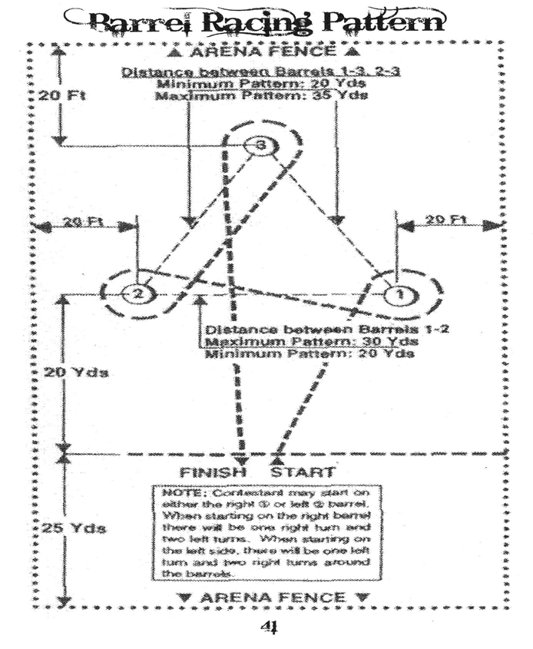

Pole Bending Race

- Permanent markers will be used to mark all pole positions, electric eye positions and start/finish line. These markers are to remain in place for the duration of the rodeo. These markers are to be checked prior to every performance by the judges and the arena director.
- A maximum or ten (10) contestants shall run at any one time before the arena is leveled or raked.
- The pole pattern will be raked at the end of the event to level the arena.
- Distance from the start line to the first pole is twenty-one (21) feet. Pole pattern to be run around six (6) poles spaced twenty-one (21) feet apart.
- Arena gate will be closed immediately after contestant has entered the arena. It will not be reopened until after the completion of the run and the rider has regained control of their horse.
- There must be a minimum of 25 feet from the last pole to the back of the arena fence.
- Poles shall be set on the ground and be six (6) feet in height with a base no larger than fourteen (14) inches and not smaller than twelve (12) inches in diameter.
- Safety bases to protect horses must be used.
- Poles must be in straight line. Gate judge will assure this is the case prior to the first contestant making their run and for every run thereafter.
- Either horse or contestant can touch poles.
- A five (5) second penalty will be assessed for each pole knocked down.
- A horse may start either to the right or left of the first pole and then run the remainder of the pattern accordingly.
- Not following pole pattern will result in a “no time”
- If horse crosses the start/finish line at anytime before pattern is completed, pattern will be considered broken and run will receive a “no time.”
- If contestant’s horse breaks timer light by backing through before starting time, time will be considered started.
- No re-run will be given for faulty equipment furnished by the contestant.

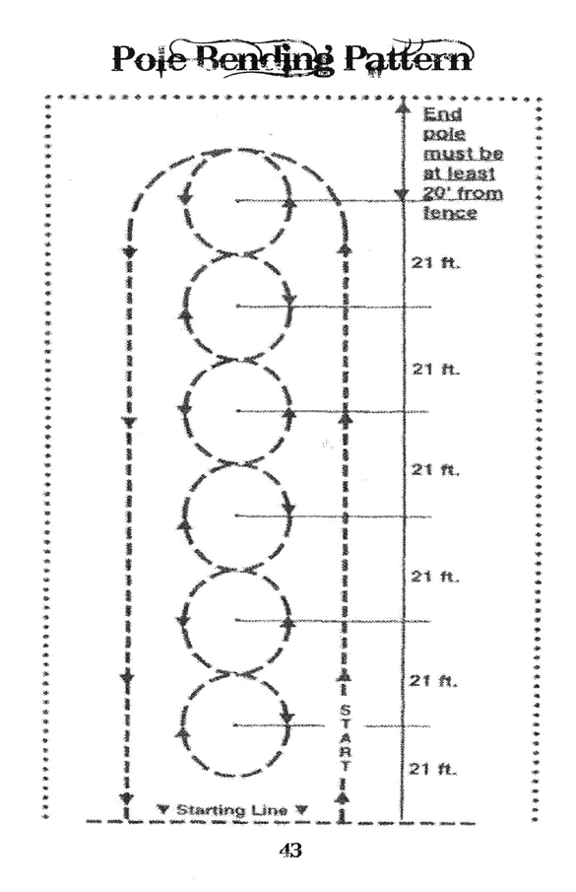
- No re-run will be given for a horse falling.

Little People Events & Rules

Events
California Stake Race Mutton Busting
Barrel Racing Pole Bending
Goat Tail Untying Dummy Roping

- Contestant can have a helper who leads them through the event. A ten (10) second penalty will be assessed to all contestants’ times that are led, or accompanied through the pattern. Helpers must be at the shoulder of the horse when going through the electric eye to start and stop the time.
- It is strongly recommended that protective helmets be worn in all events.
- Judges retain the right to stop contestant from competing should a matter of safety become an issue. Following are a few examples for illustration:
  - The child is riding a horse that they cannot control or the horse is unprepared for the event they are being asked to participate in.
  - Child is adamantly protesting having to compete in an event due to fear or other circumstances.
- Goat tail untying, If contestant’s horse is not being led, there must be a helper waiting at the point of dismount to assist in making sure the horse is stopped and the rider can safely dismount the horse. It is legal for the helper to assist the child in dismounting the horse.
- Helpers may assist contestant in physically approaching the goat and removing the ribbon. No penalty will be assessed for the amount of assistance given by the helper to the contestant.
- Judges reserve the right to make special calls regarding the Little People Division. The emphasis is on safety and success, NOT on who wins.
- Scoring rules for Mutton Busting are as follows:
  - Five (5) second time limit.
  - If a complete ride is made, the rider is scored according to standard scoring procedures.
  - If contestant comes off before the five (5) second time limit is up, they will receive a score of 0-30 points. Judges can award up to fifteen (15) points each.
  - All riders in the mutton busting must wear helmets.

SAFETY and success are the main concern with regards to the little people

CTJRA Royalty Rules

    - There will be one Queen.
    - The CTJRA Board of Directors will be the queen’s advisors.
    - The queen will be the contestant who earns the most points during the tryout.
    - The royalty will officially reign from Jan. 1-Dec. 31
    - During the year, the royalty will be responsible for assisting the CTJRA obtain sponsorships for the CTJRA year end awards, assist the Board of Directors at any fundraisers, and presentation of the year end awards.
    - Royalty may not hold 2 crowns simultaneously.
    - All CTJRA female members in the junior and senior age division’s only, who are in good standing, will be eligible to enter the contest.
    - CTJRA royalty will be announced after the selection by email and on the CTJRA.org website and in the Competitor News.
    - The royalty will be given a traveling crown and sash as well as a belt buckle, when their reign begins. The crown, sash and buckle will be provided by the CTJRA.
    - Contestants entering the royalty contest must not be or have been married, pregnant, or have children.

Caribou Trail Junior Rodeo Association

Royalty Requirements

Contestants must be an ACTIVE member of the CTJRA for 1 year, and be in the Junior or Senior division to be eligible for tryouts. You must be able to represent the Caribou Trail Junior Rodeo Association respectfully at as many rodeos as possible with an ADULT chaperone. Royalty must attend a minimum of 3 rodeos for the year and it is strongly suggested that we are represented at all other CTJRA sanctioned rodeos.

Tryout process:
Complete attached application
Horsemanship Competition –
      - Reining pattern – own horse
      - Cloverleaf pattern – own horse
      - Reining pattern – borrowed horse

JUDGING PROCESS
Horsemanship 50%
Personal Interview 25%
Speech 25%

Please mail applications to:
CTJRA P.O. Box 1919 Omak WA 98841 Attn: Queen Tryouts

Caribou Trail Junior Rodeo Association Application Royalty Applicant Name:
Age:

Address:

Phone Numbers:

Home:

Cell:

Parents Name:

Parent Phone #:
I hereby agree to have an adult chaperone if I am selected as the CTJRA Queen. I agree to be an active part of the Caribou Trail Junior Rodeo Association throughout the year. I agree that the information provided is true and accurate.

Participant signature:

Parent signature:

Required to be eligible: One of the main responsibilities of the CTJRA Queen is to obtain sponsorships and supporters for the Caribou Trail Junior Rodeo Association: As part of this application process we are requiring all candidates to turn in $300 in sponsor money which will go towards the following rodeo season. This will show the selection committee that you have the ability to present yourself and represent the association to the community at large.
1
2
3

Please complete the following questions: Why would you like to be the CTJRA Queen?

What your favorite thing about yourself?

Who are your role models?

How can CTJRA benefit from you being royalty?

What is a goal you have for next year?
CTJRA QUEEN TRYOUT GUIDELINES

CLOTHING
HORSEMANSHIP:
Western Jeans, long-sleeved western shirt, tucked in. Western hat. Chaps and gloves are not permitted.
PERSONAL INTERVIEW:
Western attire with western hat.
SPEECH:
Western Attire with western hat

PERSONALITY

The purpose of this division is to select the girl who rates the highest in:

- Intelligence (good common sense).

- Education

- Conversational ability in varied areas.

- Sense of humor.

- Genuine interest in other people and noticeable consideration of others.

- Projection (ability to project one's personality, whether it be from horseback in the arena, on television, or before an audience).

- Showmanship - (being able to present oneself in a gracious manner).

- Happy outlook on life in general.

- Promptness in keeping Pageant schedules.

INTERVIEWS

1. Personal Interviews:
During the interviews by the judges, questions asked should be serious and thought provoking. Questions should be in depth so that the judges may determine the character and knowledge of each contestant, whether they are being questioned on the sport of rodeo and related activities, horse science, or current events. Each contestant must be allowed private interviews with the judges, with the chaperones responsible for maintaining order and keeping succeeding contestants out of hearing range while the interview is being conducted. Interview length should be sufficient for contestant and judges to communicate and not be uptight.

HORSEMANSHIP

The purpose of this division is to select the girl who rates the highest in:

- Horsemanship - control of mount and the way each situation, which may occur, is handled.

- Balance - ability to sit in the saddle.

- Position of hands, feet and seat.

- Mounting and dismounting.

- The understanding and skill of the contestant will be judged, as well as grooming and cleanliness of horse and tack.

- Each contestant could be interviewed on each of the following:
  - Knowledge of Junior Rodeo, its history; organization.
  - Rodeo terminology, explanation of standard events.
  - Knowledge of tack, horse care, feeding, diseases, anatomy, etc.

- There will be three (3) categories in horsemanship. See patterns on following pages

The applicant must have her own horse and gear. The horse must be controllable in crowds and parades.

SPEECH
Speech – a three minute speech will be given on the topic of “Why Rodeo is important to you”. The speech must be memorized, there will no podium.

50

Dear Queen Parents:

We are honored to welcome you and your daughter to the CTJRA program. While it is your daughter who represents the Caribou Trail Junior Rodeo Association and embarks on a fascinating journey, it is the parent who ensures the Queens success.

You are the key! By supporting your daughter in this endeavor, you are extending a unique opportunity for her to advance as a young woman, a confident and respectful individual.

To guide you and your daughter in preparing for the extraordinary journey ahead, we have assembled this guide. It provides information on the CTJRA Queen program, along with valuable pointers and essential forms. You’ll find details on Queen Expectations and much more.

We encourage you to review this guide and discuss the contents as a family. Thank you in advance for your dedication: shuttling you daughter to and from rodeo’s parades, participating in fund-raising activities, and completing necessary paperwork. Such efforts along with your enthusiasm and encouragement make all the difference in assuring that your daughter’s experience is as wonderful as it is intended to be.

As parents, we know of the rewards that will come as your daughter embraces the joy of discovery and becomes more aware of her role as a queen, and grows in confidence and maturity. Each CTJRA Queen’s journey holds the promise of a positive life changing experience, one we are sure we all wish we’d had.

We hope you find the guide helpful, and extend the very best wishes to you and you daughter as you embark on this fascinating adventure together. Sincere regards,

CTJRA Board of Directors

51

Your Daughter’s role as CTJRA Queen

As CTJRA Queen, your daughter has the honor and responsibility of representing the Caribou Trail Junior Rodeo Association while exploring the rodeos provided in the application packet. By accepting this role, your daughter agrees to uphold the philosophy and expectations of the CTJRA Queen Program and serve as a leader and a role model along the way.

You are not only becoming a spokesperson and role model for this association but you are a valuable asset to our advertising program. Please be mindful of this and know that everyone will be expecting you to do your part in assisting us show that CTJRA is an association that the members can be proud of.

As a parent, you can impress upon your daughter the importance of this opportunity and the need to make mature and responsible choices. Encourage your daughter to keep an open mind to other cultures and ideas, and be respectful and courteous to fellow Queens, leaders, and new acquaintances. Your daughter will become enriched in more ways than imaginable.

Standards for Success

As the CTJRA Queen you are representing the membership, and as the board please understand that rules have been established to make every queen’s participation more rewarding. The CTJRA Queen program has a strict policy concerning any behavior that places the queen in harm’s way. Your CTJRA Board of Director’s requires the cooperation of the Queen in following the Standards for Success found in this guide. After you review these standards together, please have your daughter sign and return the Success Contract.

Substance Policy

CTJRA and its board of directors have a zero tolerance to drugs or alcohol and expect that the Queen will adhere to this during her reign.

Common Sense

We believe that mature CTJRA Queens know the difference between right and wrong.

When the CTJRA Queen follows her own common sense, she will be successful and appreciated.

CTJRA Queens must continually remind themselves that everything they do abroad will be observed and judged by someone, so remember to act as if your Grandmother was watching your every move. Would she be proud or ashamed of your actions?

CTJRA Queens need to represent these expectations and actions in person and on all social medias.

Dress

The following are considered inappropriate:

- Ripped or torn clothing
- Exposed undergarments
- Clothing with rude expressions or logos.
- Excessively short shirts
- Spaghetti or halter tops
- Jeans with Slits in the side or worn Cuffs

Procedures

The Royalty Director is required to take firm action in the event of serious misbehavior. A Queen may be dismissed from her duty and the First Runner up will then take over her reign.

The following procedures are used if a discipline problem occurs:
- At the first violation, the Queen receives verbal warning.
- If there is a second violation, the Royalty Director issues a written letter and calls the Queen’s parents or guardian to explain the situation.
- If the problem is not corrected, the Queen will have to give up her title and the Royalty Director will inform the Queen and her parents of this in a meeting with the Board of Directors.
- Should the Queen put herself in a situation that results in her title being revoked she will be required to forfeit all awards and scholarships she has been awarded as CTJRA Queen.

If a very serious or dangerous infraction occurs, the Queen will give up her reign, even if it is the first violation.

CTJRA Queen Success Contract

I, , understand that in becoming The CTJRA Queen, I am joining a program that offers a unique and enjoyable experience, an opportunity for personal growth and development, and a long CTJRA tradition of promoting the sport of junior rodeo.

As CTJRA Queen, my actions reflect not only me, but the association, my family and my town as well. To that purpose I will be mindful of my actions, manners, speech and conduct with others. I understand my responsibilities to be those of extending goodwill, friendship, courtesy and respect to whomever I meet, and sharing the best of who we are as CTJRA Queens.

I accept the supervision and discipline of the Royalty Director and CTJRA Board of Directors, who has been appointed to ensure a safe and rewarding growing experience for the selected Queen.

I have read and I understand the Standards for Success as stated in the Queen guide. I understand that these guidelines are necessary for my safety, security and general welfare and those of my fellow Queens. If I purposefully fail to follow those agreed-upon guidelines, I understand that I am responsible for the stated consequences of my actions.

Signature of the CTJRA Queen:

Date:

Parent Agreement

We (I) have read the Standards for Success and agree that our (my) daughter will be governed by these policies. Signature of the CTJRA Queen Parents:
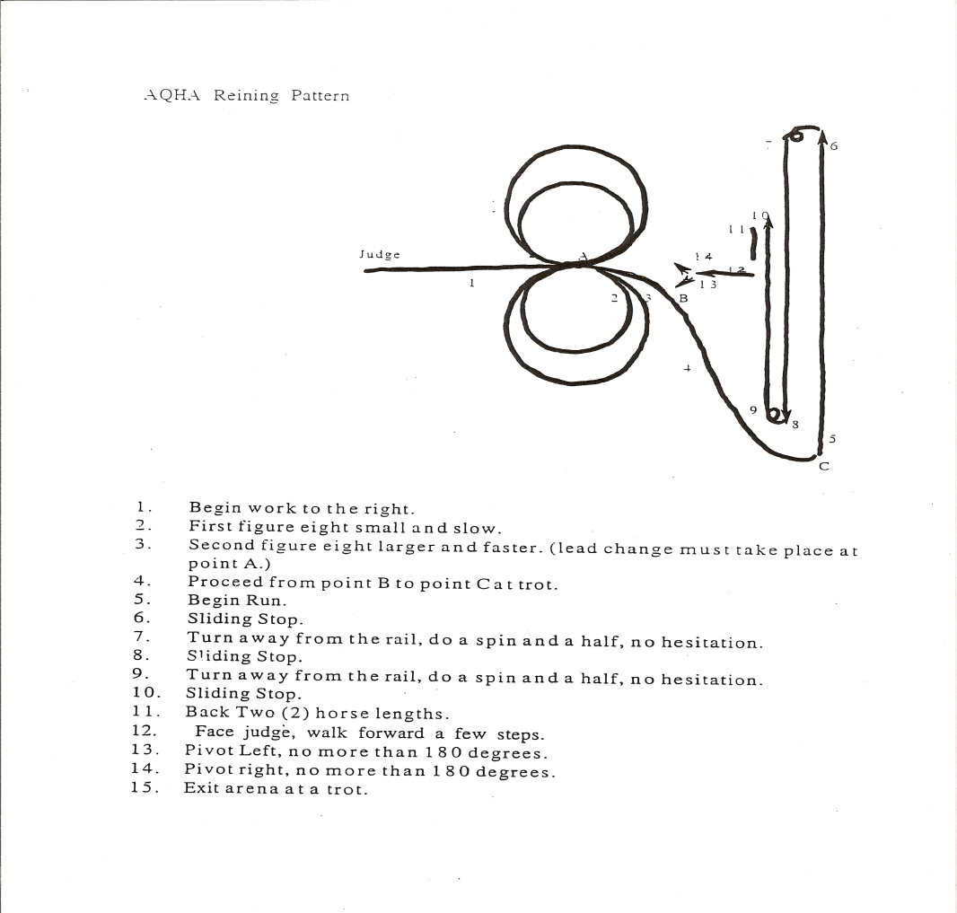Date:
55
Updated 4/2015

Lead horse to judges/Impromptu questions
  - Mount
  - Run Horsemanship pattern at a good gallop
  - Sliding stop
  - Back up three (3) horse lengths
  - Begin presentation ride
  - Sliding stop
  - Dismount/Horsemanship interview by judges
  - Exit Arena.

Cloverleaf Pattern # 2
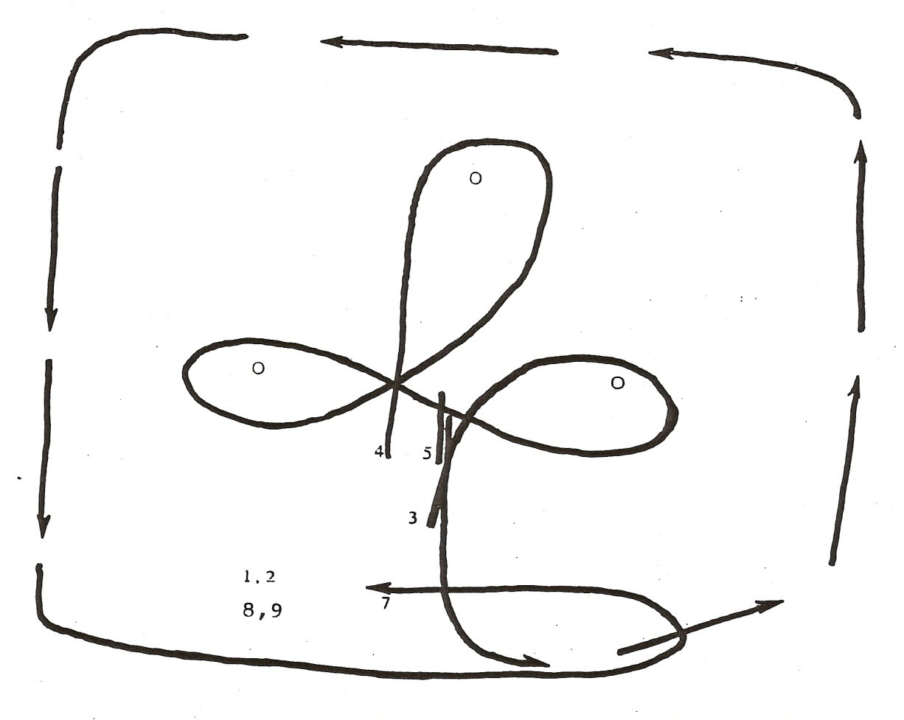

Updated 4/2015

