CTJRA Royalty Rules

    - There will be one Queen.
    - The CTJRA Board of Directors will be the queen’s advisors.
    - The queen will be the contestant who earns the most points during the tryout.
    - The royalty will officially reign from Jan. 1-Dec. 31
    - During the year, the royalty will be responsible for assisting the CTJRA obtain sponsorships for the CTJRA year end awards, assist the Board of Directors at any fundraisers, and presentation of the year end awards.
    - Royalty may not hold 2 crowns simultaneously.
    - All CTJRA female members in the junior and senior age division’s only, who are in good standing, will be eligible to enter the contest.
    - CTJRA royalty will be announced after the selection by email and on the CTJRA.org website and in the Competitor News.
    - The royalty will be given a traveling crown and sash as well as a belt buckle, when their reign begins. The crown, sash and buckle will be provided by the CTJRA.
    - Contestants entering the royalty contest must not be or have been married, pregnant, or have children.

Caribou Trail Junior Rodeo Association

Royalty Requirements

Contestants must be an ACTIVE member of the CTJRA for 1 year, and be in the Junior or Senior division to be eligible for tryouts. You must be able to represent the Caribou Trail Junior Rodeo Association respectfully at as many rodeos as possible with an ADULT chaperone. Royalty must attend a minimum of 3 rodeos for the year and it is strongly suggested that we are represented at all other CTJRA sanctioned rodeos.

Tryout process:
Complete attached application
Horsemanship Competition –
      - Reining pattern – own horse
      - Cloverleaf pattern – own horse
      - Reining pattern – borrowed horse

JUDGING PROCESS
Horsemanship 50%
Personal Interview 25%
Speech 25%

Please mail applications to:
CTJRA P.O. Box 1919 Omak WA 98841 Attn: Queen Tryouts

Caribou Trail Junior Rodeo Association Application Royalty Applicant Name:
Age:

Address:

Phone Numbers:

Home:

Cell:

Parents Name:

Parent Phone #:
I hereby agree to have an adult chaperone if I am selected as the CTJRA Queen. I agree to be an active part of the Caribou Trail Junior Rodeo Association throughout the year. I agree that the information provided is true and accurate.

Participant signature:

Parent signature:

Required to be eligible: One of the main responsibilities of the CTJRA Queen is to obtain sponsorships and supporters for the Caribou Trail Junior Rodeo Association: As part of this application process we are requiring all candidates to turn in $300 in sponsor money which will go towards the following rodeo season. This will show the selection committee that you have the ability to present yourself and represent the association to the community at large.
1
2
3

Please complete the following questions: Why would you like to be the CTJRA Queen?

What your favorite thing about yourself?

Who are your role models?

How can CTJRA benefit from you being royalty?

What is a goal you have for next year?
CTJRA QUEEN TRYOUT GUIDELINES

CLOTHING
HORSEMANSHIP:
Western Jeans, long-sleeved western shirt, tucked in. Western hat. Chaps and gloves are not permitted.
PERSONAL INTERVIEW:
Western attire with western hat.
SPEECH:
Western Attire with western hat

PERSONALITY

The purpose of this division is to select the girl who rates the highest in:

- Intelligence (good common sense).

- Education

- Conversational ability in varied areas.

- Sense of humor.

- Genuine interest in other people and noticeable consideration of others.

- Projection (ability to project one's personality, whether it be from horseback in the arena, on television, or before an audience).

- Showmanship - (being able to present oneself in a gracious manner).

- Happy outlook on life in general.

- Promptness in keeping Pageant schedules.

INTERVIEWS

1. Personal Interviews:
During the interviews by the judges, questions asked should be serious and thought provoking. Questions should be in depth so that the judges may determine the character and knowledge of each contestant, whether they are being questioned on the sport of rodeo and related activities, horse science, or current events. Each contestant must be allowed private interviews with the judges, with the chaperones responsible for maintaining order and keeping succeeding contestants out of hearing range while the interview is being conducted. Interview length should be sufficient for contestant and judges to communicate and not be uptight.

HORSEMANSHIP

The purpose of this division is to select the girl who rates the highest in:

- Horsemanship - control of mount and the way each situation, which may occur, is handled.

- Balance - ability to sit in the saddle.

- Position of hands, feet and seat.

- Mounting and dismounting.

- The understanding and skill of the contestant will be judged, as well as grooming and cleanliness of horse and tack.

- Each contestant could be interviewed on each of the following:
  - Knowledge of Junior Rodeo, its history; organization.
  - Rodeo terminology, explanation of standard events.
  - Knowledge of tack, horse care, feeding, diseases, anatomy, etc.

- There will be three (3) categories in horsemanship. See patterns on following pages

The applicant must have her own horse and gear. The horse must be controllable in crowds and parades.

SPEECH
Speech – a three minute speech will be given on the topic of “Why Rodeo is important to you”. The speech must be memorized, there will no podium.

50

Dear Queen Parents:

We are honored to welcome you and your daughter to the CTJRA program. While it is your daughter who represents the Caribou Trail Junior Rodeo Association and embarks on a fascinating journey, it is the parent who ensures the Queens success.

You are the key! By supporting your daughter in this endeavor, you are extending a unique opportunity for her to advance as a young woman, a confident and respectful individual.

To guide you and your daughter in preparing for the extraordinary journey ahead, we have assembled this guide. It provides information on the CTJRA Queen program, along with valuable pointers and essential forms. You’ll find details on Queen Expectations and much more.

We encourage you to review this guide and discuss the contents as a family. Thank you in advance for your dedication: shuttling you daughter to and from rodeo’s parades, participating in fund-raising activities, and completing necessary paperwork. Such efforts along with your enthusiasm and encouragement make all the difference in assuring that your daughter’s experience is as wonderful as it is intended to be.

As parents, we know of the rewards that will come as your daughter embraces the joy of discovery and becomes more aware of her role as a queen, and grows in confidence and maturity. Each CTJRA Queen’s journey holds the promise of a positive life changing experience, one we are sure we all wish we’d had.

We hope you find the guide helpful, and extend the very best wishes to you and you daughter as you embark on this fascinating adventure together. Sincere regards,

CTJRA Board of Directors

51

Your Daughter’s role as CTJRA Queen

As CTJRA Queen, your daughter has the honor and responsibility of representing the Caribou Trail Junior Rodeo Association while exploring the rodeos provided in the application packet. By accepting this role, your daughter agrees to uphold the philosophy and expectations of the CTJRA Queen Program and serve as a leader and a role model along the way.

You are not only becoming a spokesperson and role model for this association but you are a valuable asset to our advertising program. Please be mindful of this and know that everyone will be expecting you to do your part in assisting us show that CTJRA is an association that the members can be proud of.

As a parent, you can impress upon your daughter the importance of this opportunity and the need to make mature and responsible choices. Encourage your daughter to keep an open mind to other cultures and ideas, and be respectful and courteous to fellow Queens, leaders, and new acquaintances. Your daughter will become enriched in more ways than imaginable.

Standards for Success

As the CTJRA Queen you are representing the membership, and as the board please understand that rules have been established to make every queen’s participation more rewarding. The CTJRA Queen program has a strict policy concerning any behavior that places the queen in harm’s way. Your CTJRA Board of Director’s requires the cooperation of the Queen in following the Standards for Success found in this guide. After you review these standards together, please have your daughter sign and return the Success Contract.

Substance Policy

CTJRA and its board of directors have a zero tolerance to drugs or alcohol and expect that the Queen will adhere to this during her reign.

Common Sense

We believe that mature CTJRA Queens know the difference between right and wrong.

When the CTJRA Queen follows her own common sense, she will be successful and appreciated.

CTJRA Queens must continually remind themselves that everything they do abroad will be observed and judged by someone, so remember to act as if your Grandmother was watching your every move. Would she be proud or ashamed of your actions?

CTJRA Queens need to represent these expectations and actions in person and on all social medias.

Dress

The following are considered inappropriate:

- Ripped or torn clothing
- Exposed undergarments
- Clothing with rude expressions or logos.
- Excessively short shirts
- Spaghetti or halter tops
- Jeans with Slits in the side or worn Cuffs

Procedures

The Royalty Director is required to take firm action in the event of serious misbehavior. A Queen may be dismissed from her duty and the First Runner up will then take over her reign.

The following procedures are used if a discipline problem occurs:
- At the first violation, the Queen receives verbal warning.
- If there is a second violation, the Royalty Director issues a written letter and calls the Queen’s parents or guardian to explain the situation.
- If the problem is not corrected, the Queen will have to give up her title and the Royalty Director will inform the Queen and her parents of this in a meeting with the Board of Directors.
- Should the Queen put herself in a situation that results in her title being revoked she will be required to forfeit all awards and scholarships she has been awarded as CTJRA Queen.

If a very serious or dangerous infraction occurs, the Queen will give up her reign, even if it is the first violation.

CTJRA Queen Success Contract

I, , understand that in becoming The CTJRA Queen, I am joining a program that offers a unique and enjoyable experience, an opportunity for personal growth and development, and a long CTJRA tradition of promoting the sport of junior rodeo.

As CTJRA Queen, my actions reflect not only me, but the association, my family and my town as well. To that purpose I will be mindful of my actions, manners, speech and conduct with others. I understand my responsibilities to be those of extending goodwill, friendship, courtesy and respect to whomever I meet, and sharing the best of who we are as CTJRA Queens.

I accept the supervision and discipline of the Royalty Director and CTJRA Board of Directors, who has been appointed to ensure a safe and rewarding growing experience for the selected Queen.

I have read and I understand the Standards for Success as stated in the Queen guide. I understand that these guidelines are necessary for my safety, security and general welfare and those of my fellow Queens. If I purposefully fail to follow those agreed-upon guidelines, I understand that I am responsible for the stated consequences of my actions.

Signature of the CTJRA Queen:

Date:

Parent Agreement

We (I) have read the Standards for Success and agree that our (my) daughter will be governed by these policies. Signature of the CTJRA Queen Parents:
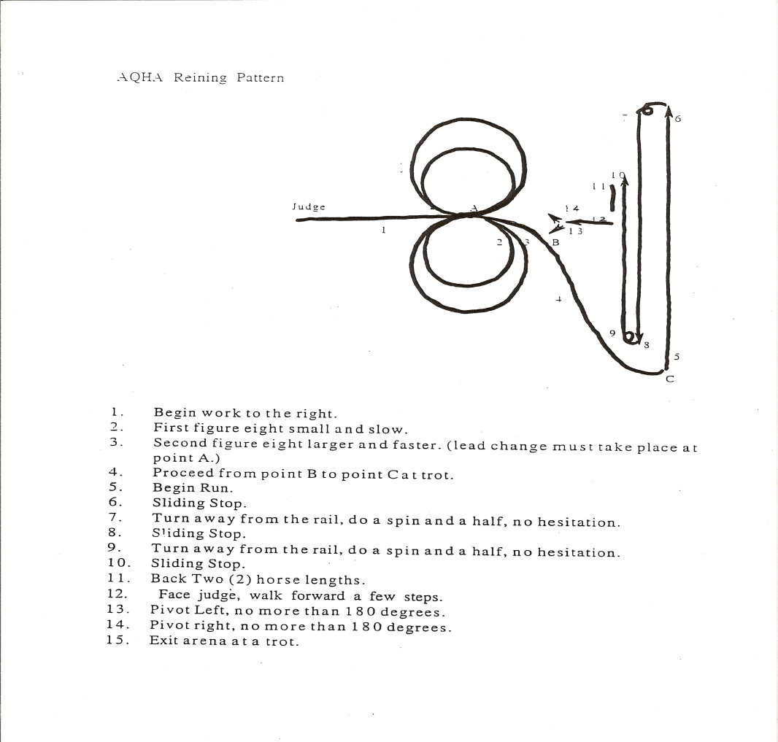Date:
55
Updated 4/2015

Lead horse to judges/Impromptu questions
  - Mount
  - Run Horsemanship pattern at a good gallop
  - Sliding stop
  - Back up three (3) horse lengths
  - Begin presentation ride
  - Sliding stop
  - Dismount/Horsemanship interview by judges
  - Exit Arena.

Cloverleaf Pattern # 2
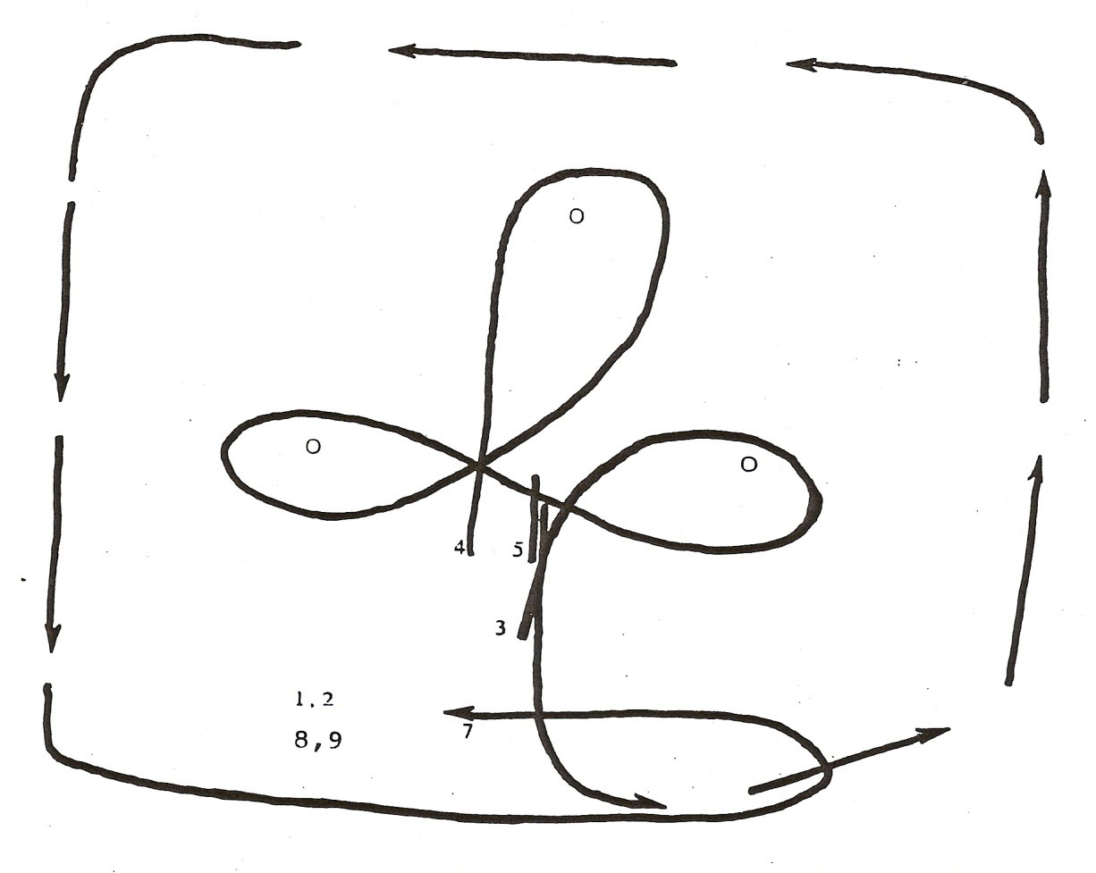

Updated 4/2015

