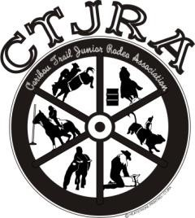
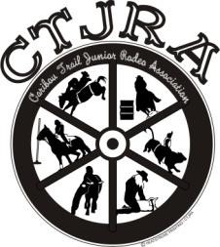
CTJRA Points Only Rodeo
Sunday, June 30, 2024
Okanogan Co Fairgrounds, 175 Rodeo Trail Road, Okanogan WA
Rodeo Start time: 10AM, ***Dummy Roping starting at 8:30AM

General Membership meeting at 9am

Name: ______________________________________ _______________
Address: ___ _____________________City: ___________ST: __ ____Zip: ____ Telephone:(_____)__________________ Age: _______ (as of 1/01/24) Birth Date: ____/____/____

Team Roping: $15___Header___Heeler___Do you want to participate in the draw pool? Yes__No_
Senior Boy 15-18 Intermediate Boy 12-14 |  | Junior Boy 9-11 | Peewee Boy 6-8
Bull Riding $25 Bull Riding $25 |  | Steer Riding $15 | Calf Riding $15
Bareback $25 Bareback $25 |  | Goat Tying $15 | Goat Flanking $15
Saddle Bronc $25 Chute Dogging $15 |  | Barrel Racing $15 | Barrel Racing $15
Chute Dogging $15_____ Breakaway $15 _ |  | Pole Bending $15 | Pole Bending $15
Calf Roping $15 | Calf Stake Tying $15 | Breakaway $15 | Dummy Roping $15
Steer Daubing $15_____ | Steer Daubing $15____ | Steer Daubing $15_____ | Cal Stake $15_____
Senior Girl 15-18 | Intermediate Girl 12-14 | Junior Girl 9-11 | Peewee Girl 6-8
Cow Riding $25 | Cow Riding $25 | Steer Riding $15 | Calf Riding $15
Goat Tying $15 | Goat Tying $15 | Goat Tying $15 | Goat Flanking $15
Barrel Racing $15 | Barrel Racing $15 | Barrel Racing $15 | Barrel Racing $15
Pole Bending $15_____  Breakaway $15_____  Steer Daubing $15_____ | Pole Bending $15_____  Breakaway $15_____  Steer Daubing $15_____ | Pole Bending $15_____  Breakaway $15_____  Steer Daubing $15_____ | Pole Bending $15_____  Dummy Roping $15_____  Cal Stake $15_____
Little People Boy and Girl 5 & Under  Goat Tail Untying $15_____  Barrel Racing $15_____  Dummy Roping $15_____  Cal Stake $15_____  Muttin Bustin’ $15_____ | Entry Fees: $_____  Camping Fee: $ 15.00  Total Fees: $______ | Checks/ Money Orders payable to:  CTJRA  PO BOX 1919  Omak, WA 98841

~Entries must be postmarked by June 14, 2024~
NO ENTRIES TAKEN THE DAY OF THE RODEO
Check/Money Order for full amount must accompany Notarized entry form.

We the undersigned, parent/guardians of ___________________________________, minor, give the ambulance, the Hospital, the Physicians, and the Medical Staff of the ambulance, the permission to administer necessary treatment for injury incurred while participating in the CTJRA points only rodeo and herby release and discharge the rodeo stock contractor, Okanogan County Fairgrounds, Okanogan County and any CTJRA officer or representative from any claim or right form damages which may occur to my SON/DAUGHTER or HORSE. I also assume and accept full responsibility for any damages done by my SON/DAUGHTER or HORSE while participating in the CTJRA Points Only Jr. Rodeo.

SIGNATURE OF PARENT/GUARDIAN________________________________________
Subscribed and sworn before me this _______day of ___________________2024.
NOTARY PUBLIC__________________________________________________________

